Chapter 2: Foreign investment proposals

Foreign investment proposals
This chapter provides an overview and statistical information on applications considered in 2013-14. It provides information on proposed investments that fall within the scope of Australia’s Foreign Investment Policy (the Policy) and the Foreign Acquisitions and Takeovers Act 1975 (the Act). The Policy and the Act can be accessed through the Board’s website, www.firb.gov.au.
The term ‘proposed investment’ is used widely throughout this report. The value of proposed investment is the aggregation of the following estimates at the time of the approval:
- acquisition costs (including shares, real estate or other assets);
- development costs following some acquisitions; and
- costs of both establishment and development in the case of new businesses.

Features of the Foreign Investment Review Board statistics

Methodological and data caveats
While this chapter provides a useful source of data on proposed foreign direct investment in Australia, the Board urges particular caution in the use of these statistics, including when making comparisons with earlier years.
- The statistics contained in this chapter do not measure total foreign investment made in any year, nor do they measure changes in net foreign ownership levels in Australia. They reflect investor intentions (not actual purchases) to acquire Australian assets. They are inherently irregular and can be skewed due to very large investment proposals and multiple proposals for the same target.
- There are also substantial differences between these statistics on proposed investments and actual investment flows. The latter are more reliably captured by Australian Bureau of Statistics data, which seeks to reflect more comprehensively investment transactions between residents of Australia and non-residents.
- Data capture and reporting methodologies change over time.
- Data presented for earlier years may also have been revised since last published.
- Proposed investment amounts for earlier years are not adjusted for inflation or currency movements.
- The figures are based on the assumption that investment funds will be sourced from overseas. The extent to which approved investment proposals will actually be funded from outside of Australia and result in foreign capital inflows depends not only upon whether they are implemented, but also upon the proportion that is financed from foreign sources. Some (and in some cases all) of the proposed funds to be invested may be contributed by Australians, for example, where they are in partnership with foreign interests, or where the investment is financed from existing Australian operations.
- The source of proposed investment identified in the Board’s statistics does not necessarily reflect the country of control. For example, the source may be attributed to a company’s single substantial shareholder, or if a company’s shares are widely held, the country of domicile or incorporation may be recorded.
- The data does not necessarily reflect a change in foreign ownership as, in some cases, both the target and the purchaser are foreign persons.
- The proposed investment of an approved proposal is the amount advised by the applicants or the best estimate based on the available information. It represents an estimate of the expected proposed investment in the 12 months from the approval unless the approval is granted for a longer period (if the proposal is in fact implemented).
  - Where an approved acquisition is a part of an offshore acquisition, the proposed investment figure is calculated based on the share attributable to the approved acquisition.
  - Where amounts are in a foreign currency, this is converted to Australian dollars based on the exchange rate at the time of the decision.
  - There are some approved proposals for which proposed investment is treated as nil. Examples of this include corporate reorganisations, financing arrangements and where foreign government investor lenders take security interests, but do not have approval to retain ownership after any enforcement of such security interests.
- The statistics may include some transactions that do not actually proceed. They include:
  - proposals that are approved in a given year but which are not actually implemented in that year or at all;
  - approvals for multiple potential acquirers of the same target (including for potential consortium participants that are yet to determine their final maximum percentage interest); and
  - approvals for shares or units where only a portion of the intended shares or units may be acquired.
- Acquisitions of diversified company groups are classified into a single industry sector according to the major activity of the group, such as in a diversified mining company with interests in various minerals. Acquisitions of real estate to be used for purposes incidental to the main business activity of the purchaser are classified according to that activity.

Policy scope and changes
The breadth of the data reflects the requirements of the Policy at the time. The data does not cover foreign investments below the various monetary and percentage thresholds that apply under the Policy and the Act. Nor does the data cover follow-on investments to expand the capital stock of existing foreign-owned businesses (both in existing areas and into related areas). See the Board’s website (www.firb.gov.au) for the current thresholds.
Furthermore, policy and legislative change can have a considerable impact on the continuity of data. For instance, changes in the Policy that have occurred since the mid-1980s have affected the number of some types of proposals, limiting comparability over time. These changes include:
- the increase in the general asset threshold in 1999 from $5 million to $50 million, and, again, in December 2006 from $50 million to $100 million;
- the increase in the offshore takeovers threshold in December 2006 from the general asset threshold (then at $50 million) to $200 million;
- the introduction of the higher $800 million threshold (indexed on 1 January each year) for United States investors from 1 January 2005;
- the harmonisation in 2009 of the four lowest thresholds for private business investment to a single threshold of $219 million (indexed on 1 January each year);
- the abolition in 2009 of the requirement for private investors to notify when establishing a new business valued above $10 million;
- the introduction of indexation in 2012 for the general monetary threshold for commercial developed real estate that is not heritage listed;
- the extension of the higher monetary thresholds available to United States investors to New Zealand investors as of 1 March 2013;
- the revised definition of foreign government investor introduced in March 2013;
- the introduction of changes in 2009 and 2010 to the screening arrangements for temporary residents purchasing residential real estate;
- the reclassification in 2009 for screening purposes of accommodation facilities from residential real estate to commercial developed real estate;
- the removal of foreign ownership restrictions in the media sector in April 2007; and
- changes in immigration policies that control the number of temporary resident visa holders, which largely determines the level of foreign investment in established (second-hand) residential dwellings.

Administrative practices
Changes in administrative practice (for example, data collection and recording practices) and application requirements have also impacted on data comparability. Examples of this include the following:
- The implementation of a new case management system in December 2005 significantly improved data collection accuracy. The system allows a more detailed analysis of proposed foreign investment, as reflected in improvements to the statistics presented from the 2005-06 Annual Report onwards.
- Reporting procedures for proposals involving financing arrangements were amended in 2005-06. Although they continue to be included in the statistics (in the number of approvals), the proposed acquisition cost and development expenditure are not recorded for proposals such as lending arrangements where there is not expected to be an equity investment flow into Australia. This has affected the value attributed to proposed investment in the finance and insurance industry.
- Prior to 2005-06, proposals involving share acquisitions were recorded as conditionally approved on the basis that the proposed acquisition was to proceed within 12 months. Now, such proposals are no longer recorded as conditionally approved.

Applications considered
This section analyses all investment proposals that were finalised (approved, rejected, withdrawn or exempt) during 2013-14, irrespective of the date they were submitted. Corporate reorganisations are included here (89 in 2013-14), whereas they are excluded from the analysis of approved investment provided later in this chapter. Corporate reorganisations occur across a range of sectors, including real estate.
The number of applications considered during 2013-14 was 25,005. Table 2.1 provides a breakdown of the number of applications considered over the past six years, according to the outcome of proposals.
- Of the 24,102 applications approved in 2013-14, 12,307 were approved subject to conditions and 11,795 without conditions being imposed. All but three conditional approvals were in the real estate sector.
  - Real estate conditions ordinarily imposed at that time include those relating to the period during which development must commence, requiring temporary residents to reside in and then sell established dwellings when they cease to reside in them, and reporting requirements.
- Three proposals were rejected in 2013-14 (compared with no rejections in 2012-13), representing less than 0.1 per cent of all proposals considered. Of the three proposals rejected, two related to residential real estate, and the other related to the rejection in November 2013 of Archer Daniels Midland Company’s proposed takeover of GrainCorp Limited.
- In 2013-14, 719 proposals were withdrawn by the applicants. Of these, around 39 per cent involved real estate proposals. Many of the real estate related withdrawals resulted from applicants submitting concurrent or a series of applications (often for properties that were to be auctioned and for which they intended to bid), and once one property had been purchased, subsequently withdrawing the remaining applications. In other cases, proposals were withdrawn because the investment was deferred or the applicant decided not to proceed for commercial reasons.
  - In some circumstances, business proposals may be withdrawn and resubmitted in order to extend the statutory deadline, particularly if there are concerns about the issuing of an Interim Order, the details of which would be published in the Commonwealth of Australia Gazette.
- During 2013-14, 181 proposals were determined to be exempt compared with 145 in 2012-13. Some applications received were determined to be outside the scope of the Policy or the scope of the Act, because they were exempt under the Foreign Acquisitions and Takeovers Regulations 1989. The existence of these particular applications reflects advice in the Policy that foreign investors submit proposals if they have any doubt as to whether the proposals are notifiable.
Table 2.1: Applications considered: 2008-09 to 2013-14
(number of proposals)
Note: Figures include corporate reorganisations (89 in 2013-14).
The 2008-09 and 2009-10 figures were impacted by changes to the screening arrangements for residential real estate, as announced in December 2008 and April 2010.

Applications decided
This section analyses all proposals that were approved (either with or without conditions), or rejected during 2013-14, irrespective of the date they were submitted. Corporate reorganisations are included.
The introduction of changes in 2009 and 2010 to the screening arrangements for temporary residents purchasing residential real estate has significantly impacted the comparability of the data across years in this section. Table 2.2 provides a breakdown of proposed investment according to the outcome of applications decided for the corresponding period provided in Table 2.1.
Table 2.2: Applications decided: 2008-09 to 2013-14
(value of proposed investment)
Note: Totals may not add due to rounding.
‘0.0’ indicates a figure of less than $50 million.
Including corporate reorganisations (89 in 2013-14, including 22 in the real estate sector).
The 2008-09 and 2009-10 figures were impacted by changes to the screening arrangements for residential real estate, as announced in December 2008 and April 2010.
Charts 2.1 and 2.2 display the figures from Table 2.1 to show the difference over the past six years between applications decided within the real estate and non-real estate sectors (other sectors) by number of proposals and value of proposed investment.
Chart 2.1 shows that, by number, most of the applications decided were within the real estate sector. Chart 2.3 shows that, by value, more of the proposed investment occurred in non-real estate sectors.
Chart 2.1: Real estate applications decided: 2008-09 to 2013-14 (number of proposals)
Note: Real estate includes number of proposals decided for commercial and residential real estate.
Chart 2.2: Non real estate applications decided: 2008-09 to 2013-14 (number of proposals)
Chart 2.3: Applications decided: 2008-09 to 2013-14 (value of proposed investment)
Note: The 2008-09 and 2009-10 real estate figures were impacted by changes to the screening arrangements for residential real estate, as announced in December 2008 and April 2010.

Approvals by value
This section analyses applications approved during 2013-14 (excluding corporate reorganisations). Table 2.3 shows approvals over the past four years by the value of proposed investment.
The overwhelming majority of approvals in the categories below $50 million relate to real estate (because of the screening thresholds). There has been a significant 94 per cent increase in real estate approvals in 2013-14.
Table 2.3: Total approvals by value and number: 2010-11 to 2013-14
Note: Totals may not add due to rounding.
Excludes corporate reorganisations (89 in 2013-14).

Approvals by sector
Table 2.4 shows applications approved in 2013-14 by industry sector. Chart 2.3 shows the sectoral distribution of approved proposed investment in 2013-14. Corporate reorganisations are excluded (89 in 2013-14).
- The 2013-14 period was marked by a significant reduction in investments into the mining sector (down by $23.1 billion), which were more than offset by increases in investments into the services sector (up by $27.5 billion).
- There was an increase in the value of investment in 2013-14 when compared to 2012-13 in services; agriculture, forestry and fishing; manufacturing; tourism and real estate.
- Sectors where there was a decrease in the value of investment in 2013-14 when compared to 2012-13 were; mineral exploration and development; finance and insurance and resource processing.
- In 2013-14, real estate remained the largest industry sector by value of approvals.
Table 2.4: Total approvals by industry sector in 2013-14
- Proposed investment includes off-the-plan approvals provided to real estate developers and approvals for annual programs. Further details are provided in the section on real estate starting on page 26.
Note: Totals may not add due to rounding.
Excludes corporate reorganisations (89 in 2013-14).
Chart 2.4: Total approvals by value by industry sector in 2013-14 (value of proposed investment)
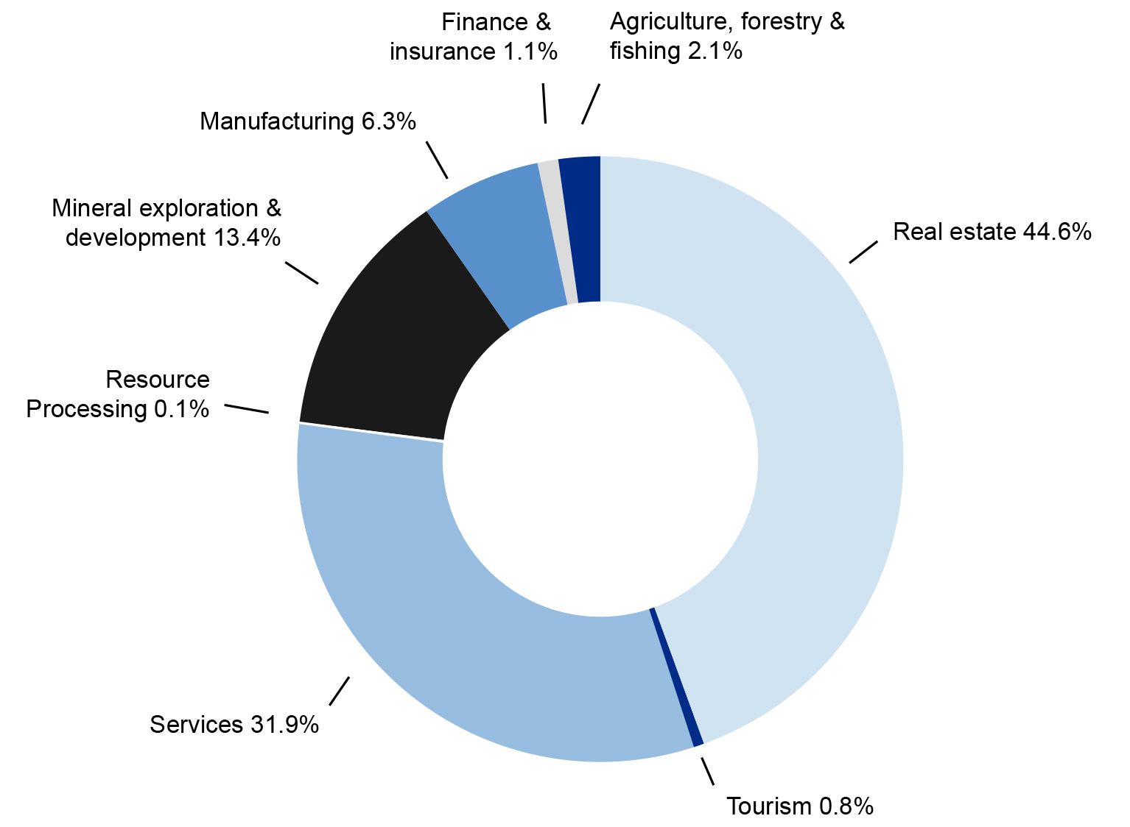
Note: Totals may not add due to rounding.

Agriculture, forestry and fishing
Proposed investment in the agriculture, forestry and fishing sector increased by value from $2.9 billion in 2012-13 to $3.4 billion in 2013-14, and the number of proposals decreased from 91 to 58 proposals. This represents around two per cent of the total value of approved investment in 2013-14. The two largest source economies of investment by value in this sector were Canada and Hong Kong ($0.6 billion), followed by the United States ($0.58 billion). Over the last five years, the average level of foreign investment in the sector has been just under $2.6 billion. Investment proposals in this sector are inherently irregular and can be skewed by large transactions with several competing bidders.

Finance and insurance
During 2013-14, 22 proposals were approved in the finance and insurance sector compared to the 36 proposals approved in this sector in 2012-13. Proposed investment decreased from $2.9 billion to $1.7 billion.

Manufacturing
The manufacturing sector saw an increase in both the number and in the value of proposals approved in 2013-14. There were 56 proposals (44 proposals in 2012-13) and proposed investment of $10.5 billion ($6.5 billion in 2012-13).
Table 2.5: Manufacturing sector approvals in 2013-14
- Includes: basic metal products; fabricated metal products; miscellaneous-manufacturing; non-metallic mineral products; paper and paper products; transport equipment; and wood, wood products and furniture.
Note: Totals may not add due to rounding.

Mineral exploration and development
Proposed investment in the mineral exploration and development sector decreased from $45.1 billion in 2012-13 to $22 billion in 2013-14. The number of approved proposals decreased from 289 to 248 proposals.
Table 2.6: Mineral exploration and development sector approvals: 2009-10 to 2013-14
- Includes: services to mining and exploration; and other non-metallic minerals.
Note: Totals may not add due to rounding.

Resource processing
Proposed investment in the resource processing sector decreased from $0.4 billion in 2012-13 to less than $0.1 billion in 2013-14, and the number of approvals decreased, from seven to three.

Services
Proposed investment by number of approvals and value in the services sector increased from 2012-13. The number of approvals increased from 154 to 195 and proposed investment increased from $26 billion to $53 billion.
Table 2.7: Services (excluding Tourism) sector approvals: 2010-11 to 2013-14
- Includes: construction; and special trade construction.
- Includes: retail and wholesale trade.
- Includes: air transport; rail transport; road transport; water transport; other transport; and services to transport.
- Includes: storage (grain and cold storage); entertainment and recreation services; other community services; and education, museum and library services.
Note: Totals may not add due to rounding.

Tourism
Proposed investment in the tourism sector in 2013-14 was $1.27 billion, up from $0.02 billion in 2012-13. The number of approved proposals increased from one to three.

Real estate

Proposals in real estate in 2013-14
Approved investment in real estate was $74.6 billion in 2013-14 (compared with $51.9 billion in 2012-13).

Residential real estate

Developed

The category of developed residential real estate consists primarily of temporary residents in Australia acquiring one existing residential property for use as their residence in Australia.

For development
Acquisitions of residential real estate for development include a number of categories.
The vacant land category consists primarily of individual blocks of land purchased for single dwelling construction. These are normally approved subject to conditions (such as, that construction begins within 24 months). It also includes broadacre land for residential subdivision and multiple-dwelling residential developments (such as townhouses and units).
The new dwellings and off-the-plan category consists of applications by individuals to acquire newly constructed dwellings directly from developers and applications by developers to sell up to 100 per cent of new residences in a development to foreign interests (the developer is also required to market the dwellings locally). Applications from individuals are normally approved without conditions. If a developer is given approval, individuals need not apply for approval. Foreign persons may purchase new residences in such developments over a number of years.
The approved investment figures for off-the-plan approvals for developers and annual programs overstate the likely extent of actual foreign purchases. The value of investment reported against annual program approvals represents the maximum amount foreign persons may acquire under the program.
Developed property for redevelopment involves the acquisition of existing property for the purpose of demolition and construction of new residential dwellings. These are normally approved as long as the redevelopment increases Australia’s housing stock (at least two dwellings built for the one demolished) or where it can be shown that the existing dwelling is derelict or uninhabitable. Approvals are usually subject to conditions (such as, that construction begins within 24 months).
Table 2.8: Investment in residential real estate by type of approval and number of proposals approved: 2010-11 to 2013-14
Note: Totals may not add due to rounding.

Commercial real estate

Developed
Foreign persons acquiring an interest in developed commercial real estate (for example, shopping centres, office buildings, warehouses, hotels and motels) that is valued at more than the applicable monetary threshold are required to notify and get prior approval before purchasing.

For development
Foreign persons need to apply to buy or take an interest in commercial land for development, regardless of the value of the land. Such proposed investment is normally approved subject to conditions (such as, that construction begins within five years).

Annual programs
The ‘annual program’ arrangements allow foreign persons to apply for an annual approval for real estate acquisitions up to a specified global monetary limit. Such an approval relieves them of the requirement to seek separate approvals for individual real estate acquisitions within the approved value and the approval year. Approvals are subject to the condition that applicants subsequently report on the actual acquisitions completed and any associated development. Applicants are also required to comply with the standard requirements that would apply under the Policy for the type of property that is to be purchased. For example, for vacant land acquisitions construction must begin within the required timeframe.
Table 2.9: Investment in commercial real estate by type of approval and number of proposals approved: 2010-11 to 2013-14
Note: Totals may not add due to rounding.

Real estate by location of investment
Table 2.10 provides details of proposed investment in the real estate sector, according to the state and territory location of the proposed investment.
Table 2.10: State and Territory distribution of proposed investment in real estate in 2013-14
- Includes approved proposals where the proposed investment is to be undertaken in more than one state or territory.
Note: Totals may not add due to rounding.
‘-‘ indicates a figure of zero.
Table 2.11 provides details of proposed investment in the residential real estate sector, according to the state and territory location of the proposed investment.
Table 2.11: State and Territory distribution of proposed investment in residential real estate by industry subtype in 2013-14
- Includes approved proposals where the proposed investment is to be undertaken in more than one state or territory.
Note: Totals may not add due to rounding.
Excludes annual programs and corporate reorganisations.
‘^’ Developer includes off-the-plan approvals provided to real estate developers. Further details are provided in the section on real estate starting on page 26.
‘-’ indicates a figure of zero or a figure less than $10 million.
‘*’ indicates between 1 and 9 approvals.

Approvals by country of investor
Proposed investment in 2013-14 by selected country, disaggregated by sector, is shown in Table 2.12. For the first time, China was the largest source of proposed foreign investment in Australia, mainly driven by a large increase in residential real estate approvals. The other major sources of proposed investment were the United States, Canada, Malaysia, and Singapore. Malaysia and Singapore replaced Switzerland and the United Kingdom in the top five sources of investment.

Table 2.12: Approvals by country of investor by industry sector in 2013-14
Note: Totals may not add due to rounding.
‘-’ indicates a figure of $10 million or less.

Notes applying to Table 2.12
- Includes overseas territories.
- China excludes Special Administrative Regions and Taiwan.
- Other comprises all other countries not in the largest 18 countries based on total proposed investment approved, as well as proposed investment approved which cannot be attributed to a country.
- One advanced off the plan certificate equates to one approval in terms of the number of approvals but the entire value of the proposed development is included in the value columns. Further details are provided in the section on real estate starting on page 26.
- Comprises proposals where an Australian controlled investment manager acting on behalf of an investor operates independently of the interest holders in the investor, or an Australian investor(s) jointly intends to make a proposed investment with a foreign investor, or jointly establish a new business with a foreign government investor.
- These figures indicate the total number of proposals in which investors from the particular country have an interest. Those involving investment originating from more than one country count as one proposal for each of the countries concerned.

Data has been compiled by reference to the Australian and New Zealand Standard Industrial Classification (ANZSIC 1993), except: newspaper printing and publishing are allocated to the services industry sector (ANZSIC 1993 classifies these under manufacturing); some manufacturing activities have been grouped together as the resource processing sector (see footnote 7); and tourism is recorded as a separate industry sector rather than being included with the other service industries.
This is similar to the existing practice for corporate reorganisations.
Applicants are required to reapply if the transaction has not taken place and they wish to proceed after the 12 month period has passed, unless they were granted approval for an extended period.
The proposed acquisition costs and development expenditure are not recorded for corporate reorganisations.
The sector includes activities that, through processing, value add to natural resources. For example, cotton ginning, flour and sugar milling, smelting and refining of mineral resources, abattoirs and wood chipping.
As of 2009, hotels, motels, hostels and guesthouses have been treated as developed commercial property. For reporting, acquisitions of: direct interests in such accommodation facilities are included in acquisitions of existing commercial property at Table 2.9; and indirect interests in such accommodation facilities, through for example the acquisition of a substantial interest in an Australian hotel business, are classified as tourism sector.
Also includes a small number of approvals relating to foreign persons that operate a substantial Australian business acquiring existing residential property to house their Australian based staff.
As of 2009, hotels, motels, hostels and guesthouses have been treated as developed commercial property. For reporting, acquisitions of: direct interests in such accommodation facilities are included in acquisitions of existing commercial property at Table 2.9; and indirect interests in such accommodation facilities, through for example the acquisition of a substantial interest in an Australian hotel business, are classified as tourism sector at page 26.

