Foreign Investment
Review Board

Annual Report
2007-08

© Commonwealth of Australia 2009
ISBN 978-0-642-74529-3
This work is copyright. Apart from any use as permitted under the Copyright Act 1968, no part may be reproduced by any process without prior written permission from the Commonwealth. Requests and inquiries concerning reproduction and rights should be addressed to:
Commonwealth Copyright Administration
Attorney-General’s Department
3-5 National Circuit
BARTON ACT 2600

Or posted at: www.ag.gov.au/cca

A copy of this document appears on the Foreign Investment Review Board website at www.firb.gov.au.

Printed by CanPrint Communications Pty Ltd.

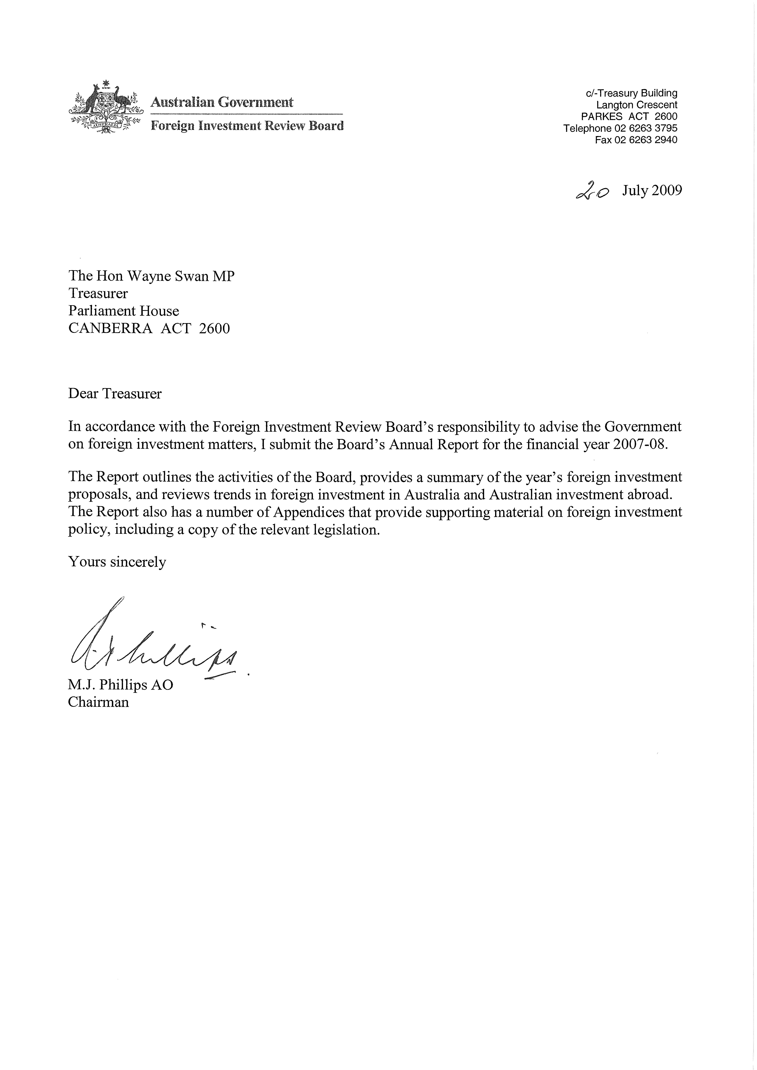

Contents
Acronyms and abbreviations ix
Glossary xi
Main points xv
Chapter 1: Foreign Investment Review Board
Functions of the Board 3
Board membership 3
Relationship of the Division to the Board 4
Administration of foreign investment policy 5
Information, advice and education 5
Consideration timeframe 5
Examination and approval process 6
Consultation arrangements 6
National interest 7
Handling of commercial-in-confidence and personal information 8
2007-08 outcomes 9
Cost of the Board’s operations 9
Consideration of proposals and enquiries 9
Changes to foreign investment policy — residential real estate 10
Monitoring and compliance activity 10
Chapter 2: Foreign investment proposals
Features of these statistics 15
Applications considered in 2007-08 18
Applications decided in 2007-08 20
Approvals by value 23
Approvals by sector 26
Agriculture, forestry and fishing 27
Finance and insurance 27
Manufacturing 28
Mineral exploration and development 29
Resource processing 29
Services 29
Tourism 30
Real estate 30
Changes to foreign investment policy — residential real estate 30
Real estate under the 2007 08 policy 31
Residential real estate 32
Commercial real estate 35
Annual programmes 35
Real estate by location of investment 37
Approvals by country of investor 38
Chapter 3: Overview of the Foreign Acquisitions and Takeovers Act 1975
Introduction 45
Notification 46
The Treasurer’s powers 47
Foreign-to-foreign transactions 48
Prior approval for contractual arrangements 48
Foreign control 49
Enforcement provisions 49
Other aspects of foreign investment policy 49
Foreign portfolio shareholdings 49
Foreign government investment in Australia 50
Taxation 51
Chapter 4: International investment issues and Australia’s international investment position
Introduction 55
Multilateral investment issues 56
OECD Investment Committee 56
OECD Guidelines for Multinational Enterprises 57
World Trade Organization 59
Asia-Pacific Economic Cooperation 59
Bilateral investment negotiations 60
Free trade agreements 60
Existing agreements 60
Current negotiations 60
FTA feasibility studies 62
Investment protection and promotion agreements 62
Australia’s international investment position 62
Foreign investment levels 63
Foreign direct investment levels by country 63
Foreign investment flows 64
Useful references on international investment issues 67
Websites 67
Documents 68
Appendices
Appendix A: Australia’s Foreign Investment Policy 71
Appendix B: Legislation and regulations, media releases and policy statements and publications 93
Appendix C: Chronology of policy measures 103
Appendix D: Foreign Acquisitions and Takeovers Act 1975 117
Appendix E: Foreign Acquisitions and Takeovers Regulations 1989 177
Foreign Acquisitions and Takeovers (Notices) Regulations 1975 197
Appendix F: OECD Guidelines for Multinational Enterprises 205
Appendix G: Contact details 225

Tables
Table 2.1: Applications considered 2002-03 to 2007-08 — number of proposals 20
Table 2.2: Applications decided 2002-03 to 2007-08 — proposed investment 20
Table 2.3: Total approvals by value 2004-05 to 2007-08 23
Table 2.4: Total approvals by industry sector in 2007-08 26
Table 2.5: Manufacturing sector approvals in 2007-08 28
Table 2.6: Mineral exploration and development sector approvals 2006-07 to 2007-08 29
Table 2.7: Services sector approvals in 2007-08 30
Table 2.8: Real estate sector approvals in 2007-08 37
Table 2.9: Real estate sector approvals in 2007-08 — location of investment 38
Table 2.10: Approvals by country of investor in 2007-08 — location of investment 40
Table 2.11: Approvals by country of investor in 2007-08 — industry sector 41
Table 4.1: Foreign investment flows 2003-04 to 2007-08 65

Charts
Chart 2.1: Applications decided 2002-03 to 2007-08 — number of proposals 22
Chart 2.2: Applications decided 2002-03 to 2007-08 — proposed investment 22
Chart 2.3: Total approvals by value 2004-05 to 2007-08 — number of proposals 25
Chart 2.4: Total approvals by value 2004-05 to 2007-08 — proposed investment 25
Chart 2.5: Total approvals by industry sector in 2007-08 — proposed investment value 27
Chart 4.1: Level of foreign direct investment by country at 31 December 2007 64
Chart 4.2: Foreign investment flows 2003-04 to 2007-08 66

