Foreign Investment

Review Board
Annual Report
2017–18
© Commonwealth of Australia 2019
ISSN 0155-0802 (print)
ISSN 2204-0927 (web)
This publication is available for your use under a Creative Commons Attribution 3.0 Australia licence, with the exception of the Commonwealth Coat of Arms, the Treasury logo, photographs, images, signatures and where otherwise stated. The full licence terms are available from http://creativecommons.org/licenses/by/3.0/au/legalcode.
Use of Treasury material under a Creative Commons Attribution 3.0 Australia licence requires you to attribute the work (but not in any way that suggests that the Treasury endorses you or your use of the work).
Treasury material used ‘as supplied’.
Provided you have not modified or transformed Treasury material in any way including, for example, by changing the Treasury text; calculating percentage changes; graphing or charting data; or deriving new statistics from published Treasury statistics — then Treasury prefers the following attribution:
Source: The Treasury.
Derivative material
If you have modified or transformed Treasury material, or derived new material from those of the Treasury in any way, then Treasury prefers the following attribution:
Based on The Australian Government the Treasury
Use of the Coat of Arms
The terms under which the Coat of Arms can be used are set out on the It’s an Honour website (see www.itsanhonour.gov.au).
Other uses
Inquiries regarding this licence and any other use of this document are welcome at:
Manager
Communications
The Treasury
Langton Crescent
Parkes ACT 2600
Email: medialiaison@treasury.gov.au
A copy of this document appears on the Foreign Investment Review Board website at www.firb.gov.au.
15 February 2019
The Hon Josh Frydenberg MP
Treasurer
Parliament House
CANBERRA ACT 2600
Dear Treasurer
I am pleased to present the annual report of the Foreign Investment Review Board (the Board) for the year ended 30 June 2018. The report has been prepared in accordance with the Board’s responsibility to advise the Government on foreign investment matters.
The Board assessed a significant volume of high profile investment applications in 2017–18. This included the acquisition of the Whyalla steelworks by British businessman Mr Sanjeev Gupta and the acquisition of Australia’s largest diagnostic imaging provider, I-MED Radiology Network, by the European private equity firm Permira.
While approvals are down by both number and the value of proposed investment, and like other similar economies we have seen a decline in proposed investment from China as Chinese authorities have tightened capital controls, foreign investor interest in Australia remains strong.
During the year, the Board continued to focus on ensuring that sensitive assets were thoroughly assessed across all dimensions of the national interest and providing early guidance to potential investors wherever possible.
With respect to national security assessments within the wider national interest focus, Australia’s approach continues to evolve in recognition of the risks and threats that emerge. During 2017-18, the Security of Critical Infrastructure Act 2018 was introduced, giving government greater visibility and oversight of critical infrastructure. The Telecommunications Sector Security Reforms were also introduced in 2018 to provide additional protection for Australia’s telecommunications sector. The Government further announced that diversity of ownership can be an important safeguard in the electricity sector, and conditions and ownership restrictions would be imposed on certain assets.
With regard to agricultural land, the Board paid close attention to the Government’s requirement that Australians be given an opportunity to acquire agricultural land for sale. The Board supported the fine tuning of this requirement over 2018.
The Board continued to engage actively with stakeholders during the year. The Board expanded the location of its board meetings to Brisbane and Perth, which facilitated valuable stakeholder discussions. One of the key messages in Board interaction with stakeholders continues to be encouraging early engagement with the Board (including prior to applications being lodged) to help manage national interest issues early and effectively.
A thoroughly revised IT system was introduced in 2018 to improve the experience of foreign investors and their advisers in lodging foreign investment applications and to enhance case management. The system deployment was successful and feedback has been positive.
Compliance with the foreign investment framework remains a priority for the Board. In
2017–18, Treasury launched a pilot series of compliance audits on previous foreign investment approvals. The pilot provided useful intelligence to support Treasury’s ongoing assurance activities and broader process improvements. It is pleasing that this work did not reveal evidence of serious non-compliance. Compliance related work is particularly important due to the increasing complexity and sensitivity of cases and we would like to see this work expanded if possible.
The Board has also taken a keen interest in foreign investment developments overseas. The United States, the United Kingdom and other countries are making significant reforms to their foreign investment regimes, particularly in respect of national security issues. I travelled to the United States to learn more about their changes first hand. While Australia has an effective foreign investment framework, it is important that we understand what other countries are doing and what we can learn from them. The Board will continue to examine ways to streamline and strengthen foreign investment review processes.
Finally, I would like to thank my colleagues for their ongoing contribution and commitment. I particularly record my appreciation for the work of Mr Patrick Secker over his five year term, and I warmly welcome Mr Nick Minchin who brings a range of skills and perspectives to the Board.
Yours sincerely
David Irvine AO
Chair

Contents
Executive Summary 1
Overview of report 3
Chapter One: The Foreign Investment Review Board 3
FIRB responsibilities 4
FIRB membership 4
Public speeches 9
FIRB agencies 9
Stakeholder engagement 10
Operational costs 11
Chapter Two: The Foreign Investment Framework 12
Foreign investment policies and priorities 12
Managing national security risks to critical infrastructure 19
The FIRB Application Portal 20
Chapter Three: Applications Data 23
Overall applications considered 24
Approvals overview 26
Approvals by industry sector 28
New business approvals 44
Investor countries 45
Variations 49
Foreign investment application fee collections 52
Chapter Four: Compliance 53
Compliance approach 53
Education and promotion 54
Penalties and enforcement powers 55
Treasury compliance activities in 2017–18 55
Residential real estate compliance activities 57
Appendix A: FIRB Meetings during 2017–18 61
Appendix B: Methodological and Data Caveats 63
Methodological and data caveats 63
Appendix C: Examination and Approval Process 69
FIRB involvement 69
Handling of commercially sensitive and personal information 69
Application screening process 70
Appendix D: Glossary 73

Tables
Table 3.1: Applications considered: 2014–15 to 2017–18 (number of applications) 25
Table 3.2: Applications decided: 2014–15 to 2017–18 (value of proposed investment) 26
Table 3.3: Total approvals by value of proposed investment range: 2014–15 to 2017–18 (number and value of approvals) 27
Table 3.4: Total approvals by industry sector: 2014–15 to 2017–18 30
Table 3.5: Manufacturing, electricity and gas sector approvals: 2014–15 to 2017–18 31
Table 3.6: Mineral exploration and development sector approvals: 2014–15 to 2017–18 33
Table 3.7: Services sector approvals: 2014–15 to 2017–18 35
Table 3.8: Commercial real estate approvals, by type: 2014–15 to 2017–18 37
Table 3.9: State and territory distribution of proposed investment in commercial real estate in 2017–18 38
Table 3.10: Residential real estate approvals, by type: 2014–15 to 2017–18 42
Table 3.11: State and territory distribution of proposed investment in residential real estate in 2017–18 43
Table 3.12: State and territory distribution of proposed investment in residential real estate, by type in 2017–18 43
Table 3.13: New business approvals by industry sector: 2014-15 to 2017-18 44
Table 3.14: Approvals by country of investor, by industry sector in 2017–18 47
Table 3.15: Variations considered: 2016–17 to 2017–18 (number of variations by variation type) 50
Table 3.16: Variations approved: 2016–17 to 2017–18 (number of variations by variation reason) 50
Table 3.17: Foreign investment fee collections: 2015-16 to 2017-18 52
Table 4.1: Residential real estate compliance investigations in 2016–17 and 2017–18 57
Table 4.2: Outcomes of residential real estate investigations that identified breaches in 2016–17 to 2017–18 58
Table 4.3: Source of residential real estate cases in 2016–17 to 2017–18 59
Table 4.4: Outcomes of completed residential real estate investigations in 2016–17 to 2017–18, by source 60
Table 4.5: Infringement notices issued in relation to residential real estate, 2016–17 to 2017–18 60
Table A.1: FIRB meeting attendance during 2017–18 61

Charts and Figures
Chart 3.1: Approvals value by industry sector: 2016–17 and 2017–18 28
Chart 3.2: Share of total value of approvals, by industry sector in 2017–18 29
Chart 3.3: Share of residential real estate approvals by state and territory in 2017–18, by number 39
Chart 4.1: Location of residential real estate breaches identified in 2017–18 59
Figure C.1: FIRB application screening process 72
Case studies and feature topics
Arrium case study 14
Business exemption certificates 17
The Chinese investment in Australia (CHIIA) database 21
Foreign investment outlook 22
Alinta Energy case study 32
I-MED Radiology Network case study 36
Trends in the Australian Housing Market 40

Executive Summary
- Australia continues to receive solid foreign investment interest as shown by the in excess of 11,000 proposed transactions approved in 2017–18, representing a combined potential investment value of $163.1 billion.
- In 2017-18, there were nevertheless declines in approvals by both number and proposed investment value for both residential and non-residential sectors. The value of approvals for the manufacturing, electricity and gas sector decreased 59.3 per cent, while the value of approvals for the services sector increased 11.8 per cent. Such large shifts are not unusual as proposed investment in a sector in a particular year may be elevated by high-value or competing proposals. Proposed investment in a sector is also impacted year-to-year by factors such as the state of the sector and sale offerings. In residential real estate, there was a decline in New South Wales’ share of approvals, which was offset by increases in Victoria and Western Australia’s shares. The decrease in residential real estate approvals by value was driven by a drop in new dwelling related approvals. Like other similar economies we have seen a decline in proposed investment from China as Chinese authorities have tightened capital controls.
- A total of 1,024 business applications worth $150.6 billion were approved in 2017–18. These figures are down from 2016–17, with 125 fewer approvals and around $17 billion less of proposed approved investment. A large portion of the decline by value in comparison to the last two financial years is attributable to a drop in the number of large proposed transactions (over $2 billion), which aligns with a decrease in sales of major energy and infrastructure assets. The last two financial years were also elevated by competing foreign bids for such major assets – the proposed foreign investment approvals data covers foreign investment approvals, not actual foreign investment, so double counting occurs when multiple investors bid for the same target.
- For the first time since 2012–13, the United States surpassed China as the largest source country for approved proposed investment due to an increase in United States approvals and a decline in Chinese approvals. The United States recorded an increase in approved investment from $26.5 billion in 2016-17 to $36.5 billion in 2017-18, with significant increases in real estate and the manufacturing, electricity and gas sector.
- China was the second largest source country following a decrease in approved proposed investment to $23.7 billion in 2017–18 from $38.9 billion in 2016–17. This reduction was due to falls in the value of approvals across all sectors. Over the last five years, Chinese proposed investment peaked at $47.3 billion in 2015–16 and also reached $46.6 billion in 2014–15. While proposed investment will not necessarily translate to actual investment and such datasets are not comparable, International Monetary Fund and Australian Bureau of Statistics data to the end of 2017 indicate that Australia has been impacted to a lesser degree by the decrease in Chinese outward investment compared to similar economies.
- In 2017–18, there was a significant increase in proposed investment approvals in service sectors, particularly in health care and the finance and insurance sector. With increased investment in these areas, protection of personal data and data security continued to be an area of focus for the Board and other agencies, such as the Critical Infrastructure Centre (CIC).
- By number of approvals, 91 per cent were for proposed investment in residential real estate worth $12.5 billion by value. This was a drop of $17.5 billion from 2016–17 reflecting a slowing in foreign demand for residential real estate.
  - The main driver of the drop by value was a decline in new dwelling related approvals, in particular, in developers seeking exemption certificates that provide pre-approval for foreign persons to purchase new dwellings in developments. However, approvals in the same category were significantly elevated in 2014-15 and 2015-16 at three to four times the average of the immediate years prior.
  - Consistent with the overarching principle of Australia’s Foreign Investment Policy that proposed investment in residential real estate should increase Australia’s housing stock, 84 per cent of approvals by number were for categories, such as new dwellings and vacant land for development, that contribute to increasing Australia’s housing stock.
  - While Chinese demand for residential real estate has fallen, China still accounts for a majority of residential real estate approvals.
- Strengthening the foreign investment compliance framework is a key area of focus. In 2017-18, Treasury completed 11 business investment audits relating to more than $25 billion of proposed investment and there was a generally high level of compliance among those audited. The Australian Taxation Office (ATO) completed around 1,400 residential real estate investigations and found 600 properties that were in breach. In most circumstances, an infringement notice was applied to these breaches. The Australian National Audit Office also completed a comprehensive performance review into the management of foreign investment compliance obligations for residential real estate. The final report was largely positive about the processes implemented by the ATO to manage compliance and additional improvements are being made as a result of the report.
- With major reforms having been made to foreign investment regimes overseas, such as in the United States and the United Kingdom, the Australian Government has enhanced its cooperation with counterpart agencies overseas, particularly in relation to national security developments. The comparatively well-developed nature of the Australian foreign investment review mechanism has been the subject of close scrutiny by other like-minded countries as part of their consideration of addressing national security and other issues relevant to their foreign investment regimes.

Overview of report
This report has four chapters and four appendices:
- Chapter one provides an overview of the Foreign Investment Review Board (the Board) and the Foreign Investment Review Board (FIRB) agencies, including responsibilities, membership and operational costs;
- Chapter two discusses the accomplishments and challenges faced by the Board and FIRB agencies in 2017–18. It reviews the changes to the foreign investment framework, stakeholder engagement conducted by the Board and FIRB agencies and the redesign of the FIRB Application Portal;
- Chapter three analyses data on foreign investment applications finalised in 2017–18. It includes approvals data by number, value, sector, and investor country. It also includes data on variations and foreign investment application fee collections;
- Chapter four explains key developments in Australia’s foreign investment framework compliance program. It discusses the approach to compliance by FIRB agencies, and the work underway to strengthen assurance that foreign persons are meeting their obligations. This includes stakeholder engagement and education, audits and investigations, and the imposition of penalties under the Foreign Acquisitions and Takeovers Act 1975;
- Appendix A lists Board members’ attendance at Board meetings;
- Appendix B provides an overview of the main methodological and data caveats that apply to applications and approvals data in this report. Of particular note in this regard is the transition, in 2017–18, from identifying the source country of proposed investment based on who controlled or likely controlled the investor, to the ultimate known underlying ownership of the investor;
- Appendix C sets out the examination and approval process for foreign investment applications; and
- Appendix D contains a glossary.

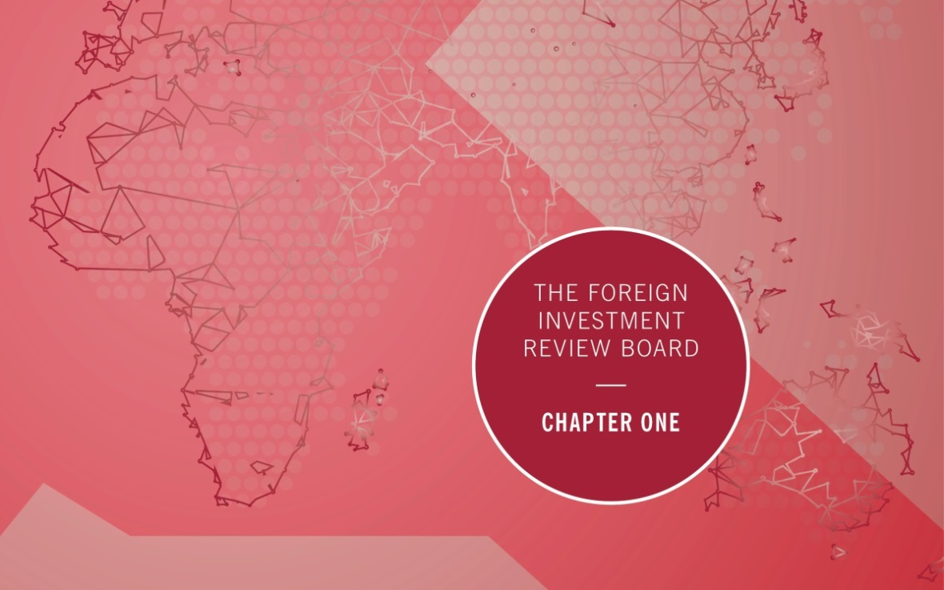

Chapter One: The Foreign Investment Review Board
This chapter provides an overview of the Board and FIRB agencies, including details on the Board’s responsibilities, the Board’s membership and operational costs.
The Board is a non-statutory body established in 1976 to advise the Treasurer and the Government on foreign investment matters. The Board’s functions are advisory only. The Board does not make binding decisions on foreign investment for government. Responsibility for making decisions on foreign investment policy and investment proposals rests with the Treasurer.
During 2017–18, the Board comprised six part-time members and a full-time executive member—the head of Treasury’s Foreign Investment Division. The Government seeks to attract members to the Board with deep knowledge and experience in a range of sectors that can actively contribute to the Board’s responsibilities. Strong probity procedures are in place to ensure any conflicts of interest that may occur are managed appropriately.
The Board considers all applications that are provided to the Treasurer for decision. To facilitate its advice, the Board meets face-to-face monthly, weekly by telephone, and out-of-session via email. Appendix A lists Board members’ attendance for the monthly face-to-face meetings during the reporting period.

FIRB responsibilities
The role of the Board is to:
- examine proposed investments that are subject to the Foreign Acquisitions and Takeovers Act 1975 (the Act) and supporting legislation, and to make recommendations to the Treasurer and other Treasury portfolio ministers on the national interest implications of these proposals;
- provide advice on the operation of the foreign investment framework and related matters;
- foster awareness and understanding, both in Australia and abroad, of Australia’s foreign investment policy;
- provide guidance to foreign persons and their representatives or agents on the operation of the foreign investment framework; and
- monitor and ensure compliance with the foreign investment framework.

FIRB membership
As at 30 June 2018, the Board comprised the following six part-time members and a full-time executive member.
- Mr David Irvine AO (Chair)
- Mr Patrick Secker
- Ms Alice Williams
- Mr David Peever
- The Hon Cheryl Edwardes AM
- Ms Teresa Dyson
- Mr Roger Brake (full-time executive member)
Mr Michael D’Ascenzo AO’s term expired on 1 January 2018 and Ms Dyson was appointed on 2 January 2018.
Since the end of the financial year, Mr Patrick Secker’s term expired on 16 December 2018 and Mr Nick Minchin was appointed from 17 December 2018.
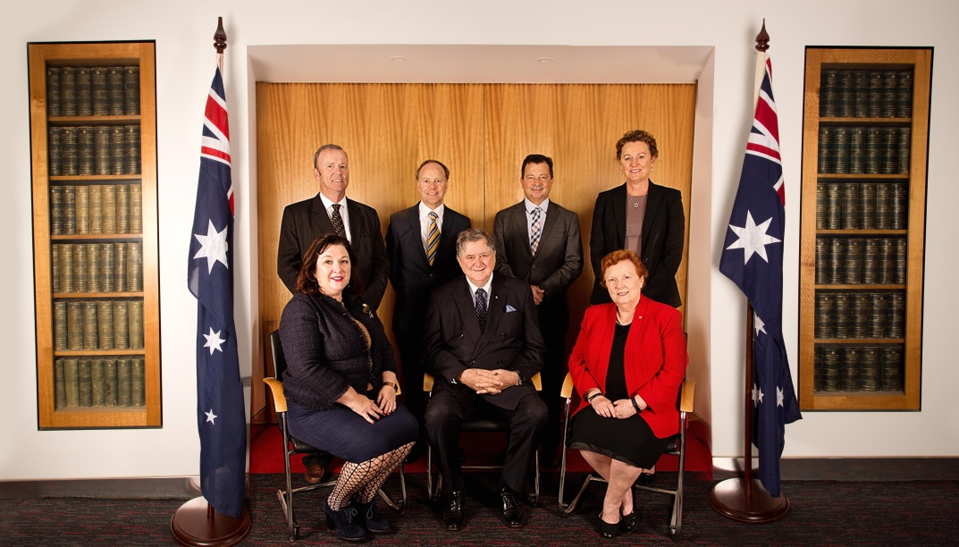
The FIRB; (left to right, back row) Patrick Secker, Roger Brake, David Peever, Alice Williams
(front row) Teresa Dyson, Chair David Irvine and Cheryl Edwardes, 15 October 2018, Brisbane.

FIRB membership as of 15 February 2019
Mr David Irvine AO

Chair and non-executive member
Chair since 16 April 2017
Member since 3 December 2015
Mr Irvine has significant national security expertise as a former Director-General of both the Australian Security Intelligence Organisation and the Australian Secret Intelligence Service. He is also a
former Australian Ambassador to China and former Australian High Commissioner to Papua New Guinea.

Other roles
Adjunct Professor – Australian Graduate School of Policy and Security at Charles Sturt University
Chair – Australian Cyber Security Centre – Cooperative Research Centre

Ms Alice Williams

Non-executive member
Member since 16 July 2015
Ms Williams has over 25 years of senior management and board level experience in the corporate and government sectors. Former directorships include Ansett Australia, the Australian Accounting Standards Board, JP Morgan, NM Rothschild and State Trustees. She
has been a consultant to listed corporations in Australia, the Gulf States and state and federal regulatory bodies.

Other roles
Commissioner – Victorian Competition and Efficiency Commission
Director – Barristers Chambers Limited
Director – Cooper Energy Ltd
Director – Defence Health
Director – Djerriwarrh Investments Ltd
Director – Racing Victoria
Mr David Peever

Non-executive member
Member since 1 February 2016
Mr Peever retired as Managing Director of Rio Tinto Australia in 2014, after 27 years with the company.
He was a member of the Prime Minister’s Indigenous Advisory Council and chaired the Defence Minister’s First Principles Review of the Defence Department. He is immediate past Chairman of Cricket Australia, a former Director of the Business Council of Australia and was Vice Chairman of the Minerals Council of Australia.

Other roles
Chairman – Brisbane Airport Corporation Group of Companies
Director – Australian Foundation Investment Company
Director – Melbourne Business School
Director – Naval Group Australia
Director – Stars Foundation

The Hon Cheryl Edwardes AM

Non-executive member
Member since 14 August 2017
Mrs Edwardes brings extensive legal and regulatory experience to the Board. Mrs Edwardes, a solicitor by profession, is a former Minister in the Court Government and was the member for Kingsley for 17 years.
In 1993, she became the first woman to be appointed Attorney General in Western Australia. Mrs Edwardes was awarded an Order of Australia in the Queen’s Birthday Honours 2016 for significant service to the people and Parliament of Western Australia.

Other roles
Commissioner – West Australian Football Commission
Director – Atlas Iron
Ms Teresa Dyson

Non-executive member
Member since 2 January 2018
Ms Dyson is a non-executive director, serving on a range of listed, public and not-for-profit boards. Ms Dyson has experience as a senior tax adviser with over 25 years of experience, including as a partner at Ashurst and Deloitte, advising on infrastructure, financing, corporate tax issues, mergers and acquisitions activities, the not-for-profit sector, and tax controversy.
She brings corporate and governance experience from a range of sectors. Ms Dyson is a former member and chair of the Board of Taxation.

Other roles
Director – Energy Qld Ltd
Director – Energy Super
Director – Genex Power Ltd
Director – Seven West Media Ltd
Director – UN Women National Committee Australia

Mr Nick Minchin

Non-executive member
Member since 17 December 2018
Mr Minchin brings wide ranging senior leadership credentials, public policy, industry and international experience to the Board.
Recently, Mr Minchin served as the Australian Consul-General in New York.
Mr Minchin held a number of ministerial positions, including as Minister for Industry, Science and Resources from 1998 until 2001 and Minister for Finance and Administration from 2001 until 2007. While in office, he held the posts of Leader of the Government in the Senate, and Vice-President of the Executive Council. Mr Minchin was elected to the Australian Senate for South Australia in July 1993 and served until June 2011.
Mr Roger Brake

Executive member
Member since 6 March 2017
The position of executive member is held by the Head of Treasury’s Foreign Investment Division. The executive member provides the link between the Board and the Treasury, which provides secretariat support to the Board.

Public speeches
During 2017–18, Mr Irvine, the Chair of the Board, gave several speeches and interviews relating to the foreign investment framework and, specifically, the systemic pressures that will influence the direction of policy. This included the keynote address at the Committee for Economic Development of Australia conference Agribusiness Outlook: Investment, Innovation and Growth and an address to the International CEO Forum.
These speeches encourage two-way dialogue between the Board and investors (or their representatives). Interactions with investors allow the Board to gain market intelligence and help it give high quality advice to the Government. Interactions with the Board allow investors to better understand the foreign investment application process.
Mr Irvine’s speeches on foreign investment are available on the FIRB website.
FIRB Chair David Irvine at the Annual Infrastructure Investors’ Forum, 14 August 2018

FIRB agencies
The Board is supported in its responsibilities by Treasury’s Foreign Investment Division and Public Groups and International in the Australian Taxation Office (ATO). Treasury and the ATO are collectively referred to in this report as ‘FIRB agencies’.

Treasury
Foreign Investment Division is responsible for advising government on all aspects of foreign investment policy. It is also responsible for the day-to-day administration of the foreign investment framework in relation to business, agriculture and sensitive or complex commercial real estate cases.

Australian Taxation Office
The ATO administers all aspects of foreign investment in residential real estate and
non-sensitive commercial real estate and corporate reorganisation cases. The ATO also has responsibility for the collection of all foreign investment application fees, and for developing and administering the registers of foreign ownership of agricultural land, water entitlements and residential land.

Stakeholder engagement
Stakeholder engagement by the Board and FIRB agencies focuses on:
- building and maintaining relationships to understand perspectives from the investment community;
- educating investors and their advisers about the operation of foreign investment rules;
- providing information and seeking feedback on foreign investment policy, processes and reforms;
- exploring specific trends and issues to ensure the Board remains informed of emerging issues; and
- working effectively with Commonwealth, state, and territory consult partners to assess foreign investment applications.

Engagement with foreign investors
Engagement with foreign investors occurs through channels including:
- the FIRB website: This includes up to date guidance material for investors, which in
2017–18 was accessed by a large number of users from around the world;
- the foreign investment enquiries hotline: In 2017–18, the ATO handled over 18,700 calls on its foreign investment enquiry line and Treasury handled over 2,800 calls. These enquiries ranged from questions about investors’ proposed acquisitions and their regulatory requirements, to media or investor queries about sectoral trends; and
- face-to-face sessions and webinars with stakeholders: FIRB agencies met with potential foreign investors, their representatives, industry peak bodies, and foreign government officials. Both Treasury and the ATO held several stakeholder meetings in 2017–18 that were tailored to promote understanding of certain aspects of the foreign investment framework, and seek stakeholders’ feedback.

Engagement with consult partners
Given the breadth of industries and transactions subject to the foreign investment framework, FIRB agencies rely on building strong relationships with key consult partners.
In 2017–18, Treasury held several meetings to enhance consult partner relationships. This included the Foreign Investment Insights Day in April 2018, which built collaborative relationships with consult partners from federal and state and territory governments. In addition, Treasury’s foreign investment team continued secondment programs with various consult partners, including the Australian Competition and Consumer Commission, the ATO, the Critical Infrastructure Centre (CIC), and private law firms. In 2017–18, the ATO held five presentations on the foreign investment framework to other government agencies and industry representatives.
Further detail on ongoing stakeholder engagement undertaken by, and on behalf of the Board, is included in the Regulator Performance Framework report.

Operational costs
The FIRB $0.5 million
Remuneration of Board members in 2017-18 was around 90 per cent of total Board expenses, with the remainder expended on travel, car hire and incidentals. Board members’ fees are determined by the Remuneration Tribunal.
Treasury $8.4 million
Expenses for Treasury’s Foreign Investment Division (FID) mainly reflect employee salary and administrative costs. Over the course of 2017–18, FID employed an average of 47 full-time equivalent Treasury staff, and a number of external contractors and consultants including lawyers from the Australian Government Solicitor. FID staff are primarily located in Canberra and Sydney.
The Australian Taxation Office $5.8 million
In 2017–18, the ATO employed 59 full-time equivalent staff, employed across the residential real estate application screening process, data matching and compliance activities, application screening of non-sensitive commercial land (vacant and non-vacant) and corporate reorganisations, and the development and maintenance of foreign ownership registers. The ATO’s teams are located across a number of sites including Sydney, Canberra, Newcastle and Melbourne.

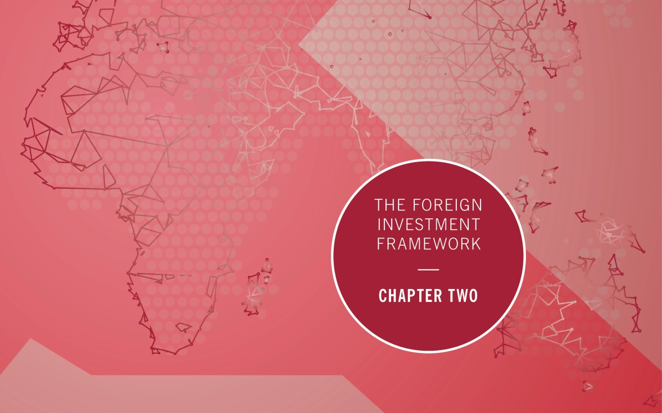

Chapter Two: The Foreign Investment Framework
This chapter discusses the changing foreign investment landscape in Australia, and the accomplishments and challenges faced by the Board in 2017–18. It outlines:
- changes to the foreign investment landscape, including to critical infrastructure regulation;
- key areas of policy focus and changes to the foreign investment framework in 2017–18; and
- the redesign of the FIRB Application Portal.

Foreign investment policies and priorities
Foreign investment helps develop domestic assets, introduces technical and management expertise, and assists Australian businesses to expand into overseas markets. Australia’s large, resource-rich land mass, proximity to fast-growing markets, easy access to finance and strong rule of law, make it an attractive investment destination.
Net inward flows of foreign direct investment to Australia averaged around $51 billion a year over the five years to 2017, ranging from $27.2 billion in 2015 to $64.2 billion in 2016.
The Australian Government maintains an open and non-discriminatory foreign investment framework that balances encouraging foreign investment flows while ensuring foreign investment is not contrary to the national interest.
The framework is designed to ensure that foreign investment is appropriately assessed, and assures the Australian public that national interest factors are properly considered. This Government, like previous Australian Governments, supports a case-by-case approach to considering foreign investment proposals. Under the Foreign Acquisitions and Takeovers Act 1975, the Treasurer can reject proposals found to be contrary to the national interest, or can impose conditions on an investment to address national interest concerns.

Arrium case study
In 2017, GFG Alliance, led by British businessman Mr Sanjeev Gupta, acquired Arrium’s steel and mining business. The acquisition included the Whyalla Steelworks, associated iron ore mines, the Port of Whyalla and the associated steel manufacturing, recycling and distribution businesses.
Arrium had been in voluntary administration for over 12 months with $4 billion in debt. The acquisition effectively saved 5,500 jobs and the viability of Whyalla.
The Board reviewed the acquisition to ensure that it was not contrary to the national interest. This particularly took into account the location and nature of the assets, and the impact on employees and the community.
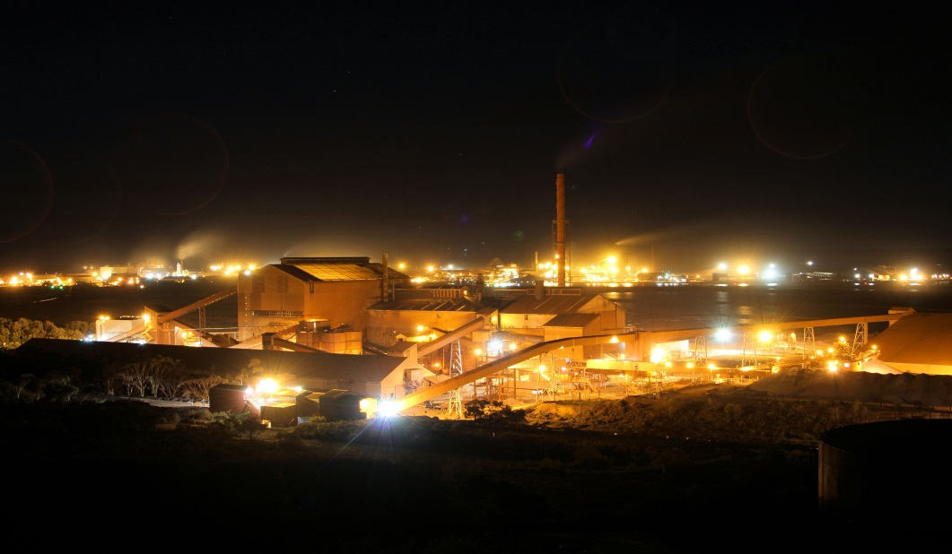
Mr Gupta’s plans included more than $1.35 billion in new investment with a significant emphasis on renewable energy projects to help reduce the steelworks’ operating costs. There are plans for pumped hydroelectric storage and an upgrade to the co-generation plant, with the major investment the construction of the 280 megawatt Cultana Solar Farm Project.
The Cultana Solar Farm Project is to be developed in 2019. It is expected to generate enough electricity for 96,000 homes, employ 350 workers during construction, and ensure greater energy security for the steelworks. Mr Gupta has also announced plans to construct the world’s largest lithium-ion battery in South Australia, creating a further 100 jobs during construction.
Whyalla Mayor Lyn Breuer was reported as saying the acquisition by Mr Gupta was a huge relief for the regional town of 22,000 people. It had lifted the cloud from over Whyalla, ending 15 months of uncertainly, during which time people had stopped spending and businesses had gone under. The Mayor said that the proposed transformation of the steelworks would transform not only the company’s operations, but also the entire community. The company’s vision for the region had the community’s full support.

The changing foreign investment landscape
Despite solid global economic growth, the backdrop for foreign investment in Australia and globally has become more challenging in recent years. In particular, heightened geo-political uncertainty and international trade tensions have resulted in foreign investors becoming increasingly selective about their investment decisions and destinations. Chinese outbound investment to Australia and the rest of the world has also slowed as authorities have tightened capital controls.
While Australia’s resources sector, which has traditionally been attractive for foreign investment, continues to receive investor interest, the services sector is now receiving greater attention. This is particularly true of health care, which experienced a $3.7 billion year-on-year increase of approved foreign investment. As foreign investors from developing economies seek to meet growing middle class consumption demands, and investors globally look to acquire advanced technology and best-practice management techniques, as well as expand their global market presence, this trend towards foreign investment in Australia’s service sector is expected to continue.
In 2017-18, the Board continued to manage a range of complexities associated with large commercial investments in sectors critical to the Australian community and economy. The past two reporting periods saw increased complexity associated with privatisation of large
state-owned electricity assets and sales of data centres combined with a heightened national security environment – in particular the security of critical infrastructure and nationally important data. While there continues to be significant foreign interest in critical infrastructure assets and data centres, 2017-18 saw growing interest in the sale of large health and financial services businesses. As with sales of data centres, these types of acquisitions raise national interest factors associated with the protection of sensitive data. Consequently, the development of data security conditions continued to be a key area of focus for the Board, to ensure a change of ownership does not present an unmanaged risk of unauthorised access to personal, government, or sensitive operational data.
The imposition of conditions on approvals continued to play an important role in enabling foreign investment to proceed while safeguarding the national interest and managing any identified risks.

Key developments in 2017–18
In the reporting period, key areas of policy focus for the Board related to implementing the regulatory changes introduced in the 2017-18 Budget, including streamlining measures and the introduction of a vacancy fee in respect of residential real estate, and policy announcements concerning the acquisition of agricultural land and electricity assets. The Board and FIRB agencies supported the establishment of the Critical Infrastructure Centre (CIC) and the Australian National Audit Office’s (ANAO) review and report, Management of compliance with foreign investment obligations for residential real estate.

Implementation of the 2017–18 Budget reforms
In 2017-18, FIRB agencies supported the implementation of a range of reforms announced by the Government in the previous reporting period, including a number of streamlining measures that came into effect on 1 July 2017.
These streamlining measures have reduced the requirement for investors to seek multiple approvals for similar low risk transactions by:
- allowing developers to re-sell to foreign persons ‘as new’ off-the-plan dwellings that failed to settle, and therefore may be considered ‘established’;
- introducing an exemption certificate so that only one approval is required for individuals considering a number of residential properties with the intention to purchase only one;
- changing fees to improve transparency and consistency, reduce complexity and achieve more equitable fee outcomes across different categories of transactions; and
- introducing a new business exemption certificate for interests in assets and securities to enable broad pre-approval for routine transactions.
Treasury worked closely with consult agencies, applicants and their advisers over the past 12 months to implement these changes, particularly processes to support business exemption certificates.
Business exemption certificates
Business exemption certificates were introduced on 1 July 2017, to provide a streamlined process for routine, low sensitivity transactions. They minimise the regulatory cost of the foreign investment framework on investments of relatively low value and sensitivity.
Rather than having to notify prior to each separate acquisition, a business exemption certificate allows a foreign person to apply only once for pre-approval for multiple acquisitions of assets or securities over a specified period and up to a specified monetary limit. The certificates are suited to large investment funds, particularly those with low risk foreign government investors. For these funds, the exemption certificates reduce the regulatory cost that would have been associated if separate applications were required for multiple acquisitions. The certificate also suits investors who may not have exact target acquisitions in mind when they seek approval, but intend to make a series of passive investments in sectors or industries that typically do not raise national interest concerns.
The certificates are available in addition to existing exemption certificates for the acquisition of land and land entities, and mining and exploration tenements.

The Australian National Audit Office (ANAO) report on residential real estate compliance
In 2017-18, FIRB agencies supported the ANAO review and report Management of compliance with foreign investment obligations for residential real estate, which was tabled in parliament in June 2018.
The report presents a comprehensive review of the arrangements the Government implemented in December 2015 to strengthen compliance with residential real estate rules. This included the transfer of administrative responsibility for residential real estate from Treasury to the ATO along with additional enforcement powers. The ANAO report is largely positive about the arrangements implemented, finding that overall, ATO processes for investigating compliance with the residential real estate rules are effective. It noted the significant work undertaken by the ATO to develop processes and systems to support the detection and investigation of non-compliance with foreign investment obligations for residential real estate.
The report made practical recommendations to improve the ATO’s effectiveness in detecting non-compliance and reporting. The ATO has already commenced work to implement these recommendations, including compiling an overarching compliance and enforcement strategy, and implementing outstanding data matching rules to aid the detection of key compliance risks.
The report contained no specific recommendations for Treasury but the ANAO did observe that the public guidance material could be simplified to ease navigation. Treasury is in the process of reviewing and updating its guidance material and the FIRB website.

Implementation of the residential real estate vacancy fee
In the 2017–18 Budget, the Government introduced enhanced rules for foreign investors to ensure that more homes are available for Australians by introducing a vacancy charge for houses left vacant for more than six months. Foreign persons who purchased a dwelling after 9 May 2017 are required to lodge an annual vacancy fee return. If the dwelling has not been genuinely occupied as a residence or available for rent for at least 183 days in the previous 12 months foreign persons will have to pay a vacancy fee.
The ATO administers the vacancy fee and uses its extensive data matching capability against a variety of sources, together with community information to monitor compliance. In June 2018, a new online vacancy fee return, along with guidance material and a pre-recorded webinar were published on the ATO’s website. To support implementation of the new requirement, the ATO has a comprehensive communications strategy in place and has engaged extensively with foreign persons and their advisers to raise awareness of the fee, including conducting:
- face-to-face visits with over 20 foreign investment advisers (each representing more than 100 applicants); and
- live webinars, targeted at foreign investment advisers through the tax practitioner community, and lawyers and conveyancers through industry associations.

Policy announcements in 2017–18

Australian electricity assets
On 1 February 2018, then Treasurer, the Hon Scott Morrison MP, issued a media release announcing that all future sales of electricity transmission, distribution and generation assets would attract ownership restrictions or conditions for foreign buyers.
The announcement recognised the important role played by critical electricity infrastructure in underpinning a range of services to the community. In some cases, aggregated ownership of critical infrastructure may increase risks to national security and maintaining diversity of ownership at the company and country level operates as an important national security safeguard.
The announcement formalised the approach already being applied at the time when assessing the national interest on a case-by-case basis. It provided a clear signal that existing levels of foreign ownership in an asset, within a sector or subsector are considered when assessing foreign investment applications. The announcement responded to requests for greater clarity around the types of factors taken into account when assessing foreign investment applications in this sector.

Agricultural land sale processes
On 1 February 2018, the Treasurer also issued a media release clarifying the importance of an open and transparent sale process when assessing applications for acquisitions of agricultural land.
The Government recognises that investment in agriculture is important for growth and innovation and contributes to the prosperity of local businesses, rural communities and the broader economy. However, it is essential that the right checks and balances are in place to ensure that foreign investment is not contrary to the national interest, including that Australians are provided with the opportunity to bid for agricultural land.
Concerns around the ability of Australians to participate in sales processes for agricultural land acquisitions were a factor in previous foreign investment decisions, including the 9 December 2016 approval for the acquisition of S. Kidman & Co Limited. Again, the announcement provided greater clarity to foreign investors wishing to purchase agricultural land that the sales process is an important factor when assessing whether a proposed acquisition is in the national interest.
Treasury engaged a range of stakeholders following the announcement to raise awareness of the requirement and develop practical guidance to support implementation of the policy. In September 2018, in response to stakeholder feedback, the foreign investment framework’s online guidance notes were updated and clarified to ensure the requirement is appropriately targeted.

Managing national security risks to critical infrastructure
In the 2017–18 reporting period, the Board and the Treasury continued to address risks to critical infrastructure in a comprehensive and proactive manner. Treasury maintained a key role in the implementation of the newly established CIC and passage of the Security of Critical Infrastructure Act 2018 (SOCI Act).
The CIC, now within the Department of Home Affairs, was established in February 2017 to support a more comprehensive approach to manage national security risks to critical infrastructure that can arise through foreign investment and supply chain arrangements. In the reporting period, Treasury participated in a range of stakeholder consultations on the role of the CIC, particularly with respect to the CIC’s role as a source of expert advice to the Board and the Treasurer for foreign investment transactions, and the development of the SOCI Act.
The SOCI Act came into force on 11 July 2018, and provides information-gathering powers to the CIC, a ministerial directions power, and establishes a register of critical infrastructure assets in Australia’s highest risk sectors (water, ports, electricity and gas). The SOCI Act applies to domestic and foreign owned assets.
The SOCI Act complements separate legislation that came into force on 18 September 2018 to manage national security risks to the telecommunications sector, the highest risk critical infrastructure sector. The SOCI Act, telecommunications sector security reform legislation and the foreign investment framework provide the Government with a framework to manage national security risks that may arise from foreign involvement in Australia’s highest risk critical infrastructure sectors.
Over time, the work of the CIC to identify and manage risks to critical infrastructure will provide a more proactive approach to manage key risks, including those that require management through any future foreign investment review process.

The FIRB Application Portal
The FIRB Application Portal is the main channel through which foreign investors apply to invest in Australia. In 2017–18, in response to stakeholders’ feedback, the Portal was redesigned to deliver a more flexible, user-friendly experience. The redesign removed a number of barriers to make it easier for foreign investors to submit applications. Improved functionality was delivered through an enhanced fee calculator, the ability to lodge one application for multiple notifiable actions, and the ability to lodge a variation application for an earlier approval or exemption certificate.
To support foreign investors’ transition to the Portal, a comprehensive communication strategy was implemented. This ensured that foreign investors were not only aware of the system enhancements, but were given an opportunity to test their understanding of the system before it ‘went live’ on 2 July 2018 and provide input into its development.

The Chinese investment in Australia (CHIIA) database
The CHIIA database, a database maintained by the Australian National University, collects information on mainland Chinese direct commercial investment in Australia and covers foreign direct investment in Australia that is undertaken, controlled or effectively controlled by mainland Chinese investors. It includes individual commercial transactions of all sizes by the date the investment is completed rather than when it is proposed or an agreement is entered into.
CHIIA contains data based on ultimate control or beneficial ownership rather than data on the country the money came from before entering Australia. This is important as the immediate source of the investment does not necessarily reflect ultimate control or ownership of the investment.
Some key findings from the CHIIA database include the following:
Mainland Chinese investment is concentrated in particular sectors. For instance, mining accounted for a quarter of the total Chinese investment in the
four year period 2014 to 2017.
Mining, and rental, hiring and real estate services, and transport, postal and warehousing are the three sectors which received the largest share of Chinese investment during 2014 to 2017.
There is considerable variability of investment by sector. For example, the transport, postal and warehousing sector was in the top three sectors for each year, except for 2017 when there was no investment in that sector.
Over the four year period less than 20 per cent of transactions involved state-owned investors. However, by value of investment they accounted for around 47 per cent of all investment over the period.

Foreign investment outlook
In addition to screening foreign investment applications and administering the foreign investment framework, the Board and FIRB agencies also monitor the foreign investment landscape including by engaging with market participants. Engagement with stakeholders suggests that the finance and insurance sector, and the health sector, are expected to experience significant activity over the next 12 to 24 months. Globally, health sector mergers and acquisitions have experienced significant activity with nearly US$306 billion of deals announced through the first half of 2018. Industry contacts suggest that aged care, radiology, and supplements are anticipated areas of interest in the Australian market.
Australia has experienced a recent rebalancing of net inflow of foreign direct investment away from mining and into non-mining sectors such as infrastructure and construction. This has been supported by elevated infrastructure spending across the country. Though state governments’ privatisation programs have moderated, investor interest in state government assets continues.
In addition to the sectors noted by market participants, foreign investment applications for the second half of 2018 suggest that the mining, transport and infrastructure, utilities, and media sectors are also likely to experience strong activity over 2018–19 and beyond.
While the global investment environment is subject to change and uncertainty, there are significant opportunities for Australia from traditional sources of Foreign Direct Investment (FDI) including the United States and the United Kingdom, and from new sources such as China or Malaysia. Global FDI fell sharply in the first half of 2018 following the US tax reforms, although announced greenfield investments – an indicator of future growth – increased relative to the same period last year.
FDI inflows from China to Australia have moderated recently, which partly reflects China’s continuing use of capital controls. We expect continued interest from the United States, the United Kingdom and China in advanced technology, health care and agriculture, but a softening of Chinese investment in real estate.

Chapter Three: Applications Data
This chapter provides an overview of all applications that were finalised during 2017–18, irrespective of the date the application was submitted. The term ‘proposed investment’ is used often in this report. The value of proposed investment for acquisitions (including securities, real estate or other assets) is the consideration agreed between the parties or, if not yet agreed, a reasonable estimate at the time of the application. Expected investment for new businesses is not collected.
There are a number of caveats that need to be applied in interpreting FIRB data. These are set out in detail in Appendix B. Importantly, approvals data does not measure actual total foreign investment made in any year or changes in net foreign ownership levels in Australia. This is because, while a foreign person may be approved to make an acquisition, the acquisition may not proceed. Further, notification is subject to screening thresholds, and therefore not all acquisitions are captured. Approvals data does not measure actual total foreign investment made in any year or changes in net foreign ownership levels in Australia. Trends in actual investment are measured by the Australian Bureau of Statistics (ABS).
Policy or legislative changes, and changes to reporting methodologies over time, can limit the comparability of data year-to-year. Approvals data can also be impacted by one or more large one-off proposed transactions, affecting the comparability of industry data across years.
This chapter deals with applications considered and the related approvals during 2017–18, followed by information on variations during the same period. The variations considered are for existing approvals, certificates and orders given during 2017–18 or earlier. Application fee collection amounts reported by the ATO are listed at the end of the chapter.

Overall applications considered
In 2017–18, the total number of applications considered, excluding variations, was 11,855. Of the 11,150 on which a decision was made (that is, not otherwise withdrawn or exempt), 11,145 were approved for $163.1 billion of proposed investment. This represents a decline from the 14,357 approvals for proposed investment of $197.7 billion in 2016–17 (see Tables 3.1 and 3.2).
The decline in foreign investment application numbers since the introduction of application fees in December 2015, particularly for residential real estate, reflects in part that foreign persons now apply when they are confident about investing. Specific factors that may have contributed to declines or increases in particular sectors are noted at the discussion of the relevant sectors.

Conditional approvals
Where an application raises national interest concerns, such as potential tax risks, conditions can be imposed on the approval to mitigate the potential risks and ensure the proposed investment is not contrary to the national interest. In 2017–18, the number of approvals made subject to conditions increased by around three percentage points to around 43 per cent of the total number and over 75 per cent of the total value of approvals. For non-real estate approvals, the majority of conditions related to tax.

Rejections and other outcomes
In 2017–18, two applications were rejected, meaning the proposed investments were prohibited from proceeding. One of these was in residential real estate and the other related to a proposed purchase of agricultural land for residential development purposes. For information on investments that were required to be divested due to being in breach of the framework, see Chapter Four: Compliance.
There were three exemption certificate applications which the Treasurer declined. In such cases, the decision is without prejudice to the foreign person separately applying for approval for each of the acquisitions that would otherwise have been covered by the exemption certificate if it had been granted. This reflects that there are situations where, for the Treasurer to be satisfied that a proposed investment is not contrary to the national interest, it is necessary for the Treasurer to know the specific assets, land or securities interest that is proposed to be acquired and their character. Where an application is declined, a fee remission would normally be considered. There were no exemption certificates revoked during the period.
In 2017–18, 644 applications were withdrawn prior to a decision being made. Around
80 per cent of these related to residential real estate applications. In the residential real estate sector withdrawals may result from applicants submitting a series of applications and subsequently withdrawing their remaining applications once they purchase a property or if the property subject to the application has been sold to other parties. In general, applications may be withdrawn because a foreign person decides not to proceed with a purchase or to defer a purchase for commercial reasons. Also, in competitive bid or tender processes a foreign person may not be shortlisted or be unsuccessful prior to a decision on their application. A small number of withdrawals may relate to assets, land or securities being withdrawn from sale by a vendor, or to the investor consortium composition changing following the submission of an application.
In 2017-18, 61 applications were determined to be exempt. Exempt refers to where applications have been lodged for a proposed investment that is subsequently determined to be exempt due to the proposed investment meeting the criteria for an exemption in the Foreign Acquisitions and Takeovers Act 1975 (the Act) or factors such as the proposed investment not meeting a threshold to be subject to the Act.
Table 3.1: Applications considered: 2014–15 to 2017–18 (number of applications)
- As of 2017-18, residential land approvals have included a condition to register on the Residential Land Register. Where this is the only condition of the approval, for reporting purposes the approval has been classified as Approved without conditions.
Notes: Excluding exempt applications, to be counted as an application considered, any required foreign investment application fee must have been paid or waived.
Variations considered are not included here. These are separately reported at Tables 3.15 and 3.16.
Numbers include corporate reorganisations and new businesses. This data is excluded from other approvals analysis in this chapter, unless otherwise noted. The numbers also include one approval to enter into an agreement in relation to an Australian business. This is included in later analysis.
Data on declined applications is not separately available for years before 2017-18.
Data from 2015–16 onwards was impacted by the 1 December 2015 reforms. Data from 2016-17 onwards was impacted by the limiting foreign ownership in new developments reform announced in the 2017-18 Budget that had immediate effect from Budget night, 7.30pm on Tuesday 9 May 2017. The 2017-18 data was impacted by the other reforms announced in the 2017-18 Budget, which were given effect on 1 July 2017. These reforms may affect data comparability.
Residential retrospective approval numbers are included here, in other applicable tables in this chapter and in Table 4.2, Chapter Four: Compliance.
Table 3.2: Applications decided: 2014–15 to 2017–18 (value of proposed investment)
- As of 2017-18, residential land approvals have included a condition to register on the Residential Land Register. Where this is the only condition of the approval, for reporting purposes the approval has been classified as approved without conditions.
Notes: Totals may not add due to rounding.
‘0.0’ indicates a figure of less than $50 million.
Figures exclude corporate reorganisations (119 approved in 2017–18) and new businesses (20 approved in 2017-18), since they are attributed $0 value. Corporate reorganisations and new businesses are also excluded from earlier year data.
Data on declined applications is not separately available for years before 2017-18.
Data for 2016-17 has been amended from earlier published data to reflect an upward revision of residential real estate values. These revisions have also been applied to Tables 3.3, 3.4, and 3.10.
Data for 2015–16 onwards was impacted by the 1 December 2015 reforms. Data from 2016-17 onwards was impacted by the limiting foreign ownership in new developments reform announced in the 2017-18 Budget that had immediate effect from Budget night, 7.30pm on Tuesday 9 May 2017. The 2017-18 data was impacted by the other reforms announced in the 2017-18 Budget, which were given effect on 1 July 2017. These reforms may affect data comparability.

Approvals overview
As noted earlier, the value of approvals in 2017–18 was less than the level recorded in
2016–17, and substantially less than the value of approvals in 2015–16. However, the values in the three years prior to 2017-18 were elevated in comparison to earlier years, partly due to multiple competing approvals for high value targets.
The number and value of approvals worth less than $500 million fell between 2016-17 and 2017-18. Approvals valued between $500 million and $2 billion grew by number and value over the same period. There were only two approvals valued at more than $2 billion in 2017-18, compared with 13 in this category in 2016–17 and 18 in this category in 2015–16.
Table 3.3: Total approvals by value of proposed investment range: 2014–15 to 2017–18 (number and value of approvals)
Notes: Totals may not add due to rounding.
Figures exclude corporate reorganisations (119 approved in 2017–18) and new businesses (20 approved in 2017-18), since they are attributed $0 value. Data prior to 2017-18 has been amended to exclude new business approvals as these are now separately reported at Table 3.13.
Data from 2015–16 onwards was impacted by the 1 December 2015 reforms. Data from 2016-17 onwards was impacted by the limiting foreign ownership in new developments reform announced in the 2017-18 Budget that had immediate effect from Budget night, 7.30pm on Tuesday 9 May 2017. The 2017-18 data was impacted by the other reforms announced in the 2017-18 Budget, which were given effect on 1 July 2017. These reforms may affect data comparability.

Approvals by industry sector
Chart 3.1: Approvals value by industry sector: 2016–17 and 2017–18
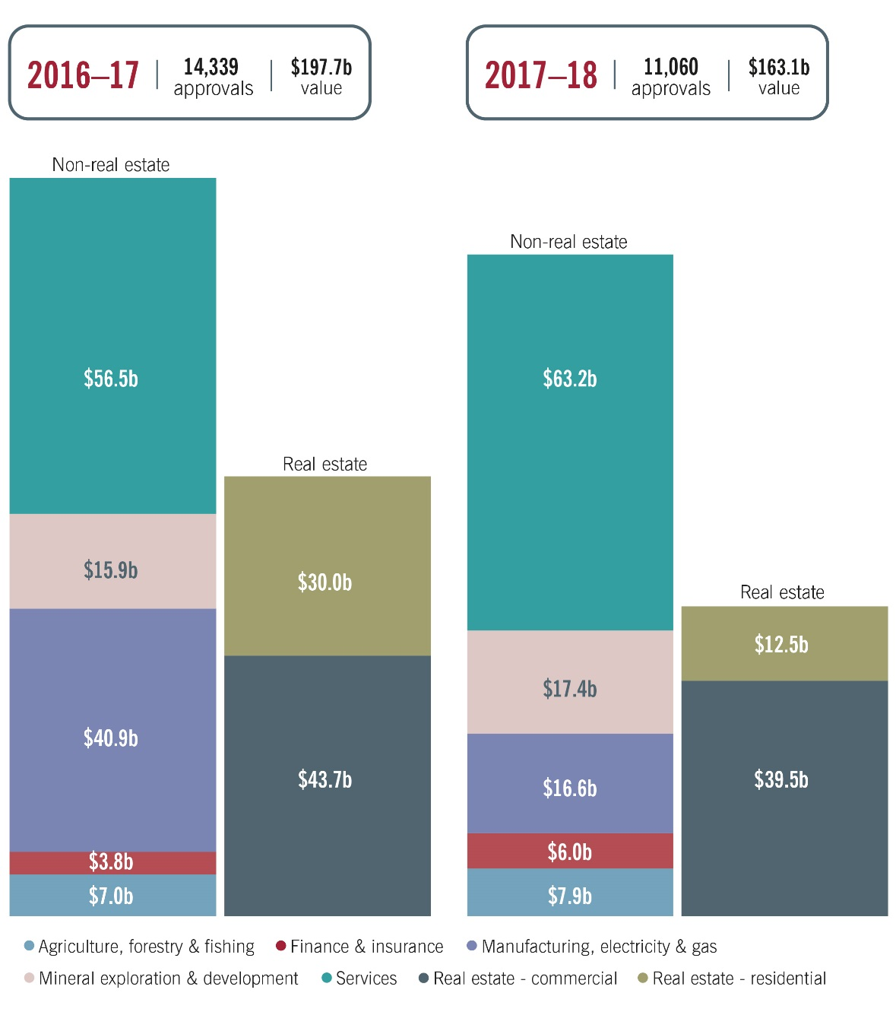
Chart 3.2: Share of total value of approvals, by industry sector in 2017–18
Notes applying to Charts 3.1 and 3.2
The total number of approvals in Chart 3.1 is recorded by target acquired, reflecting the industry sector of the target. See notes to Table 3.4 for examples.
Corporate reorganisations (119 approved in 2017–18) and new businesses (20 approved in 2017-18) are excluded.
Data for 2016-17 has been amended from earlier published data to reflect an upward revision of residential real estate values.
Data for 2015–16 onwards was impacted by the 1 December 2015 reforms. Data from 2016-17 onwards was impacted by the limiting foreign ownership in new developments reform announced in the 2017-18 Budget that had immediate effect from Budget night, 7.30pm on Tuesday 9 May 2017. The 2017-18 data was impacted by the other reforms announced in the 2017-18 Budget, which were given effect on 1 July 2017. These reforms may affect data comparability across time.
In 2017–18, the services sector attracted the highest value of approved investment, totalling $63.2 billion. The value of approvals increased from 2016–17 to 2017–18 in several other sectors. Total investment approvals increased by $0.9 billion in the agriculture, forestry and fishing sector (totalling $7.9 billion), by $2.2 billion in the finance and insurance sector (totalling $6.0 billion), and by $1.5 billion in the minerals and exploration sector (totalling $17.4 billion).
In other sectors, however, the value of investment approvals fell from 2016–17 to 2017–18. The largest fall in value was for approvals in the manufacturing, electricity and gas sector ($16.6 billion in 2017–18, down $24.3 billion from 2016–17), followed by residential real estate ($12.5 billion, down $17.5 billion from 2016–17), and commercial real estate ($39.5 billion, down $4.2 billion from 2016–17).
In 2017-18, the approval numbers for non-residential applications were down compared to earlier years. However, this may be partially offset by the availability of variations to existing approvals as of 1 December 2015, alleviating the need for a new approval in some cases. Excluding the impact of state privatisations on the manufacturing, electricity and gas sector in 2015-16 and 2016-17, the value of non-residential approvals has been relatively stable during the period. There has been a notable increase in the value of approvals for the services sector from 2016-17 onwards. However, over 40 per cent of the value in 2017-18 is attributable to one approval for Unibail-Rodamco to merge with Westfield Corporation.
Residential approvals increased significantly from 2013-14, peaking in 2015-16 at proposed investment of $72.4 billion, before experiencing significant declines in 2016-17 and 2017-18. By property type, the increase and the decline were driven by new dwelling related approvals (see Residential real estate later in this chapter).
Table 3.4: Total approvals by industry sector: 2014–15 to 2017–18
- Proposed investment includes new dwelling exemption certificates provided to real estate developers (previously off-the-plan approvals) and approvals for land exemption certificates. Further details are provided in the section on real estate.

Notes: Total number of approvals in Table 3.4 is recorded by target acquired, reflecting the industry sector of the target. For example, one application to acquire two targets (under the single agreement) that operate in separate sectors will appear as two approvals, with one approval recorded per sector. If they operate in the same sector, this will appear as two approvals recorded against the sector.
Totals may not add due to rounding.
Excludes corporate reorganisations (119 approved in 2017–18) and new businesses (20 approved in 2017-18), but includes all exemption certificates, including eight business exemption certificates in 2017-18 for total proposed investment up to $3.1 billion. Earlier year data has also been amended to exclude new business approvals as these are now separately reported on at Table 3.13.
Reflecting a methodology change and greater alignment with the Australian and New Zealand Standard Industrial Classification (ANZSIC, 2006), the time series data for mineral exploration and development and services sectors has been amended from earlier published data.
Data for 2015–16 onwards was impacted by the 1 December 2015 reforms. Data from 2016-17 onwards was impacted by the limiting foreign ownership in new developments reform announced in the 2017-18 Budget that had immediate effect from Budget night, 7.30pm on Tuesday 9 May 2017. The 2017-18 data was impacted by the other reforms announced in the 2017-18 Budget, which were given effect on 1 July 2017. These reforms may affect data comparability.

Agriculture, forestry and fishing
In 2017–18, there were 201 approvals granted for $7.9 billion worth of proposed investment in the agriculture, forestry and fishing sector. The largest source countries of investment by value in this sector were Canada ($2.6 billion), China ($1.6 billion) and the United States ($0.8 billion).
$7.9b
approved
investment
On 1 March 2015, the agricultural land screening threshold was lowered from $252 million per acquisition to $15 million cumulative. This means that more agricultural land applications, particularly for lower value transactions, were screened from this time.

Finance and insurance
The value of approved proposed investment in the finance and insurance sector was $6.0 billion in 2017–18. This was an increase of $2.2 billion on the value of proposed investment in 2016–17.
$6.0b
approved
investment
The United States was the largest source country of investment by value in this sector ($1.7 billion), followed by Canada ($0.8 billion) and the United Arab Emirates ($0.6 billion).

Manufacturing, electricity and gas
The $16.6 billion worth of proposed investment approved in 2017–18 in the manufacturing, electricity and gas sector was less than half the value recorded in 2016–17. This was despite an increase in the number of approvals and a number of high value transactions in 2017–18.
$16.6b
approved
investment
The decline in value from the previous year was driven by a $24.2 billion decrease in the value of approvals in the electricity and gas sector. The high value of approvals in the sector in 2015–16 and 2016–17 partly reflected the sale of significant parts of the New South Wales Government’s electricity transmission networks. This included the proposed multi-billion dollar acquisition of Transgrid in 2015.
The United States was the largest source country of investment by value in this sector ($3.7 billion), followed by Canada ($2.7 billion) and the United Kingdom ($2.7 billion).
Table 3.5: Manufacturing, electricity and gas sector approvals: 2014–15 to 2017–18
- Comprises: textile, leather, clothing and footwear manufacturing; polymer product and rubber products manufacturing; primary metal and metal product manufacturing; fabricated metal products manufacturing; transport equipment manufacturing; machinery and equipment manufacturing; and furniture manufacturing.
Notes: Totals may not add due to rounding.
Excludes corporate reorganisations and new businesses.
Data for 2015–16 onwards was impacted by the 1 December 2015 reforms. Data from 2017-18 was impacted by the reforms announced in the 2017-18 Budget, which were given effect on 1 July 2017. These reforms may affect data comparability.
Alinta Energy case study
Foreign investment in renewable energy projects brings many benefits to rural communities and their economies, including employment, cheaper energy sources and increased capital to local retail and service industries.
In 2018, the Board reviewed the proposed acquisition of leasehold interests in agricultural land to develop the Yandin Wind Farm in Western Australia by a subsidiary of the Hong Kong privately-owned energy generator and retailer Alinta Energy Pty Ltd.
Once built, the Yandin Wind Farm is expected to be one of the largest wind farms in Western Australia, producing enough electricity to supply the equivalent of up to 225,000 homes.¹
The project is located approximately 170 kilometres north of Perth. It is expected to take up to 18 months to complete construction.
One of the Board’s key considerations is the economic impact of proposals. Alinta Energy advised that in excess of 100 people will likely be employed during the construction phase and there would be further permanent positions for operation and maintenance. Landowners will also benefit from the leasehold rentals from their land.
Yandin Wind Farm is expected to operate for at least 25 years and is estimated to save more than 700,000 tonnes of greenhouse gas emissions each year.²
1. Based on average electricity consumption for a Western Australian home of 5,000kWh per annum.
2. Information in this case study is reflective of the expectations of the project at the time of report publication. The actual figures may be subject to change through the construction and operation of the project.

Mineral exploration and development
In 2017–18, there were 115 approvals in the mineral exploration and development sector, with a proposed investment value of $17.4 billion. This was an increase on the value of proposed investment of $1.5 billion on 2016–17. The decline in the number of applications submitted in the sector in recent years is consistent with the broader decline in mining investment in the Australian economy.
$17.4b
approved
investment
The United States ($4.8 billion), China ($3.8 billion) and Indonesia ($1.8 billion) were the largest source countries of investment by value in the sector.
Table 3.6: Mineral exploration and development sector approvals: 2014–15 to 2017–18
- Comprises: mining of ores (antimony, beryllium, bismuth, manganese, tin, tungsten, and uranium), iron pyrite, molybdenite, tantalite, platinum group metal and other metallic ore mining.
Notes: Time series includes amended data from earlier publication reflecting a methodology change and greater alignment with the Australian and New Zealand Standard Industrial Classification (ANZSIC, 2006).
Totals may not add due to rounding.
Excludes corporate reorganisations and new businesses.
Data for 2015–16 onwards was impacted by the 1 December 2015 reforms. Data from 2017-18 was impacted by the reforms announced in the 2017-18 Budget, which were given effect on 1 July 2017. These reforms may affect data comparability across time.

Services
There were 185 approvals for proposed investment in the services sector in 2017–18, a decrease of 30 approvals on the previous year.
$63.2b approved
investment
In 2017–18, the United States was the largest source country of proposed investment by value in the services sector with $19.7 billion of proposed investment. This was nearly double the value of the second largest source country, the United Kingdom, with $10.0 billion in proposed investment in the services sector.
The services sector approvals data is typically affected by large one-off transactions. In June 2018, the Paris-based commercial real estate company, Unibail-Rodamco, merged with the Australian based shopping centre operator, Westfield Corporation, for a proposed investment value of over $28 billion. This approval largely explains the increase in the value of proposed acquisitions in property and business services from $700 million in 2016–17 to $35.1 billion in 2017–18 (see Table 3.7).
The other notable aspect of service sector approvals in 2017–18 was the high value of proposed investment approvals in the health sector ($7.3 billion) relative to proposed investment in 2016–17 ($3.6 billion). In 2017–18, there were the following two significant investment proposals in Australia’s health sector:
- the $1.6 billion proposed takeover of Australian medical device company, Sirtex Medical, by Varian Medical Systems, a United States company specialising in radiation and oncology treatments; and
- there were competing bids for the acquisition of Australia’s largest diagnostic imaging provider, I-MED Radiology Network. Details of Permira’s subsequent acquisition are on page 36.
Table 3.7: Services sector approvals: 2014–15 to 2017–18
- Comprises: accommodation; food and beverage services.
- Comprises: heritage activities; creative and performing arts; sports and recreation and gambling.
- Comprises: publishing (including internet); motion picture and sound recording activities; broadcasting (including internet); and telecommunication services (including internet).
- Comprises: building construction; heavy and civil engineering construction and services to construction.
- Comprises: hospitals; medical and other health care services; residential and social assistance services.
- Comprises: property and real estate operators; professional, scientific and technical services; computer system design services; and administrative services.
- Comprises: wholesaling of basic material, machinery and equipment, grocery, liquor and tobacco products; and retailing of fuel, food and other store based retailing.
- Comprises: road, rail, water, air and space, postal and courier (pickup and delivery), warehousing and storage; and transport support services.
- Comprises: repair and maintenance; public administration; defence; and education related services.
Notes: Time series includes amended data from earlier publication reflecting a methodology change and that arts and recreation services, which was previously separately reported as tourism, has been included in this table as of this report so there is greater alignment with the Australian and New Zealand Standard Industrial Classification (ANZSIC, 2006).
Totals may not add due to rounding.
Excludes corporate reorganisations and new businesses.
Data for 2015–16 onwards was impacted by the 1 December 2015 reforms. Data from 2017-18 was impacted by the reforms announced in the 2017-18 Budget, which were given effect on 1 July 2017. These reforms may affect data comparability across time.
I-MED Radiology Network case study
In 2018 the Board reviewed the acquisition of Australia’s largest diagnostic imaging provider, I-MED Radiology Network, by the European private equity firm Permira for $1.25 billion. I-MED’s business included 200 clinics with about 20 per cent of the $3.6 billion a year diagnostic imaging market in Australia.
Permira’s acquisition of I-MED provided opportunities for further consolidation, increased capital for investment in advanced technologies and the potential for international expansion. Permira’s intentions are to grow the business and drive operational efficiencies, which would lower overhead costs and reduce fees for consumers. I-MED has subsequently acquired Western Australia’s third largest radiology business InSight Clinical Imaging.
An increasingly important aspect of the Board’s assessment is that of safeguarding Australians’ personal data. Conditions related to access of personal health data and where that data is stored are considered for acquisitions in the health sector.

Commercial real estate
In 2017–18, there were 391 approvals for $39.5 billion of proposed investment in the commercial real estate sector. This compares with 465 approvals for $43.7 billion in proposed investment in 2016–17.
$39.5b
approved
investment
The decline in value was due to fewer existing commercial property approvals. This trend was also observed in 2016–17. It may also reflect that as of 1 December 2015, exemption certificates have been able to be granted for periods longer than 12 months, which could lead to a trend of less frequent higher value exemption certificates impacting the data. The 2017–18 data on commercial property may also partly reflect a higher foreign investment screening threshold for Chinese investors as a result of the China-Australia Free Trade Agreement (ChAFTA).
ChAFTA came into effect on 20 December 2015. As of this date, Chinese investors (other than foreign government investors) are only required to obtain investment approval before purchasing developed commercial property valued above $1,094 million indexed annually (previously $252 million indexed annually). This is consistent with screening thresholds for many other foreign persons from countries with which Australia has established free trade agreements.
In contrast to the downward trend by value for developed commercial property, proposed investment in commercial real estate for development, where no threshold applies, is trending upwards.
Table 3.8: Commercial real estate approvals, by type: 2014–15 to 2017–18
- From 1 December 2015, annual programs under the new provisions in the Act are known as exemption certificates for foreign persons. They are no longer limited to a 12 month period.
Notes: Totals may not add due to rounding.
Excludes individual approvals for corporate reorganisations (some corporate reorganisations may be covered by exemption certificates).
Data for 2015–16 onwards was impacted by the 1 December 2015 reforms. Data from 2017-18 was impacted by the reforms announced in the 2017-18 Budget, which were given effect on 1 July 2017. These reforms may affect data comparability across time.

Table 3.9: State and territory distribution of proposed investment in commercial real estate in 2017–18
- Comprises approvals where the proposed investment is to be undertaken in more than one state or territory.
Notes: Totals may not add due to rounding.
Excludes individual approvals for corporate reorganisations (some corporate reorganisations may be covered by exemption certificates).
Includes exemption certificates.
‘0.0’ indicates a figure of zero or a figure less than $50 million.
The 2017-18 figures were impacted by the reforms announced in the 2017-18 Budget, which were given effect on 1 July 2017. The reforms may affect data comparability.

Residential real estate
In 2017–18, a total of 10,036 residential real estate applications were approved for proposed investment worth $12.5 billion. This is a 3,162 decline in the number of approvals from 2016–17, and a
$17.5 billion decline in the value of approvals.
$12.5b approved investment
There are many factors which, combined, may explain the fall in the number and the value of residential real estate approvals from 2016-17 to 2017-18. Anecdotal evidence from Treasury’s business liaison program points to a drop off in demand from overseas buyers. Contacts have cited state taxes and foreign resident stamp duty increases, foreign investment application fees, tightening domestic credit and increased restrictions on capital transfers in home countries, as some of the factors dampening foreign demand.
Analysis of changes in residential approvals data in comparison to 2016-17 indicates that 74 per cent of the $17.5 billion fall in overall residential real estate approvals can be attributed to a drop in new dwelling approvals. In turn, 88 per cent of the decline in new dwelling approvals was attributable to a drop in approvals for new dwelling exemption certificates (NDECs). NDECs allow developers to receive pre-approval for foreign persons to purchase new dwellings in the specified development up to a cumulative total of $3 million per foreign person.
Part of the drop in NDEC values is because of the reduction to the maximum proportion of new dwellings in a development that foreign persons can acquire using the certificate. In the 2017-18 Budget, a 50 per cent limit on the number of dwellings in a development that can be sold to foreign persons was introduced. As such, from 9 May 2017, a NDEC for a development worth $250 million for all apartments would now be valued at $125 million to account for the limit. However, the average value of an NDEC has dropped more than 50 per cent, which indicates that the measure is not wholly responsible for the significant decrease in the value of NDECs.
In 2017–18, 70 per cent of all residential real estate approvals given to a single state or territory were for purchases in Victoria or New South Wales. However, the value of residential real estate approvals in these two states roughly halved compared to the previous financial year.
Chart 3.3: Share of residential real estate approvals by state and territory in 2017-18, by number
Notes: This Chart excludes approvals that apply to more than one state or territory.
The Northern Territory has not been allocated a share for the purpose of this Chart due to the proportionately small number of approvals.
Due to the above and rounding this Chart does not add to 100 per cent.

Trends in the Australian Housing Market
The Australian housing market has slowed, with combined capital city dwelling prices falling for 16 consecutive months to January 2019 to be 7.8 per cent lower than their recent peak in September 2017. The recent moderation is unsurprising following rapid price growth between 2012 and 2017, and capital city housing prices are around 35 per cent higher overall than in 2012. Price declines have been largest in Sydney (down by 12.3 per cent from their peak in July 2017) and Melbourne (down by 8.7 per cent from their peak in November 2017), with smaller price falls registered in Perth and Darwin.
Nevertheless, residential construction activity remains elevated by historical standards and has grown strongly from the beginning of 2018 following a brief decline in 2017. Dwelling investment is expected to remain elevated in the near term supported by a solid pipeline of work yet to be constructed, although recent weakness in new dwelling approvals means that some moderation in the future level of activity remains likely.

Established residential dwellings
In 2017–18, there were 1,615 approvals for established residential dwellings. Established dwellings (or developed residential premises) can generally only be purchased by temporary residents for use as their home while they remain in Australia. A small number of approvals are given for foreign persons that operate a substantial Australian business to acquire an established dwelling to house Australian-based staff.
Established dwelling single purchase exemption certificates comprised a third of all established dwelling approvals. These certificates enable foreign persons to receive pre-approval to purchase a single established dwelling and notify the details of the property once purchased, rather than requiring the person to seek individual approvals for each dwelling they may be considering purchasing. In 2016–17, these exemption certificates were broadened to allow foreign persons to acquire a single dwelling through any purchase method, whereas previously these certificates were limited to purchases through an auction process only.

For development
Australia’s foreign investment policy encourages foreign investment in the residential real estate sector, which is expected help build new supply. During 2017–18, 8,421 approvals for development were given including approvals for new dwellings, vacant land and other residential property for development.
In addition to the decrease in NDEC approvals, there was a 62 per cent decline in the number of exemption certificate approvals compared with 2016-17. This can be explained by the number of approvals in 2016-17 being an elevated figure, at almost double the number approved in the prior financial year. One factor that may have contributed to the high value of exemption certificates in 2016-17 was that as of December 2015 these certificates could be granted for purchases to be carried out over a number of years, whereas previously they were limited to a 12 month period. This could have elevated the number of approvals in 2016-17 as, rather than wait and apply annually, foreign persons acquired several multi-year exemption certificates. This would reduce the need for an exemption certificate in the 2017-18 financial year.
Residential real estate approvals for development as a proportion of total residential real estate approvals have declined in comparison to previous years and represent around 81 per cent of the value of all residential approvals in 2017–18 (compared with 90 per cent in 2016–17). Notwithstanding this decrease, the majority of approvals continue to be for development and this aligns with Australia’s foreign investment policy, which seeks to attract investment that increases the housing stock.
Table 3.10: Residential real estate approvals, by type: 2014–15 to 2017–18
- Exemption certificates to purchase one established dwelling, known as established dwelling exemption certificates, were introduced from 1 December 2015. Initially the certificates were only available if purchasing at auction. As of 2016-17 the certificates were expanded to cover purchase by any method. Exemption certificates for the certificate holder to purchase one lot of vacant land or one new dwelling were introduced from 1 July 2017.
- From 1 December 2015, annual programs, under the new provisions in the Act are known as exemption certificates for foreign persons. They are no longer limited to a 12 month period.
Notes: Totals may not add due to rounding.
‘0.0’ indicates a figure of zero or a figure less than $50 million.
EC refers to Exemption Certificates.
An approval category that was not available during a financial year is denoted by ‘na’.
The value ascribed to a new dwelling exemption certificate is the total estimated sales value of the new dwellings in the development available for purchase by foreign persons. The value recorded is as provided by the applicant when applying for the exemption certificate. From the 2017–18 Budget onwards, approved new dwelling exemption certificates only allow developers to sell a maximum of
50 per cent of dwellings in a development to foreign persons.
Data for 2015–16 onwards was impacted by the 1 December 2015 reforms. Data from 2016-17 onwards was impacted by the limiting foreign ownership in new developments reform announced in the 2017-18 Budget that had immediate effect from Budget night, 7.30pm on Tuesday 9 May 2017. Data from 2017-18 was impacted by the other reforms announced in the 2017-18 Budget, which were given effect on 1 July 2017. These reforms may affect data comparability.
Table 3.11: State and territory distribution of proposed investment in residential real estate in 2017–18
- Comprises approvals where the proposed investment is to be undertaken in more than one state or territory.
Notes: Totals may not add due to rounding.
Includes exemption certificates.
‘0.0’ indicates a figure of zero or a figure less than $50 million.
The 2017-18 figures were impacted by the reforms announced in the 2017-18 Budget, which were given effect on 1 July 2017. The reforms may affect data comparability.
Table 3.12: State and territory distribution of proposed investment in residential real estate, by type in 2017–18
- Comprises approvals where the proposed investment is to be undertaken in more than one state or territory.
- ‘Developer’ includes new dwelling exemption certificates provided to real estate developers (previously off-the-plan approvals), as well as near new dwelling exemption certificates.
Notes: Totals may not add due to rounding.
This table excludes the developed, and for development exemption certificates for foreign persons shown in Table 3.10.
‘0.0’ indicates a figure of zero or a figure less than $50 million.
The 2017-18 figures were impacted by the reforms announced in the 2017-18 Budget, which were given effect on 1 July 2017. The reforms may affect data comparability.

New business approvals
Foreign government investors require approval to start an Australian business. The number of new business approvals in the services sector in 2017-18 more than doubled on 2016-17, returning to a similar number of approvals to that in 2015-16. Finance and insurance new business approvals also increased on recent years.
Table 3.13: New business approvals by industry sector: 2014-15 to 2017-18
Notes: A proposed investment value is not attributed to new business approvals.
Prior to the inclusion of this table from 2017-18, new business approvals were reported in approvals by industry sector.
As commercial and residential real estate relate to acquisitions of land, these industry sectors are not included in this table.

Investor countries

Methodology change
The methodology for recording foreign investment approvals by country changed in 2017–18, to more closely align with the ownership reporting methodology adopted for the foreign ownership registers. This change limits the comparability of 2017–18 data with earlier FIRB country data to the extent that ‘country of control’ and ‘country of ownership’ may differ for some foreign persons.

Leading sources of proposed investment
Table 3.14 shows proposed investment approvals in 2017–18, disaggregated by industry sector, for the top 18 countries by approvals value. The United States and China continued to be the two top sources of proposed investment by value in 2017–18. However, for the first time since 2012-13, the United States surpassed China as the largest source country, by value, for approved proposed investment.
The value of approvals from United States investors increased from $26.5 billion in 2016–17 to $36.5 billion in 2017–18. Key sectors of interest for the United States included the services sector (which increased in approvals value from $12.7 billion in 2016–17 to $19.7 billion) and the manufacturing, electricity and gas sector (which increased in approvals value from $983 million in 2016–17 to $3.7 billion).
As mentioned earlier, there was a notable decrease in 2017–18 in both the number of applications and the value of proposed investment from China. In 2017–18, there was a 30 per cent fall in the number of approvals from China, and almost a 40 per cent decline in the value of these approvals (from $38.9 billion to $23.7 billion). In 2017–18, there was a marked fall in the value of approvals from China in the manufacturing, electricity and gas sector, the mineral exploration and development sector, the services sector, and in real estate.

Unibail-Rodamco’s approved merger with the Australian headquartered and ASX listed Westfield Corporation, which valued Westfield Corporation at over $28 billion, had a notable impact on the rankings for 2017–18. Unibail-Rodamco is dual listed on French and Dutch stock exchanges. The Netherlands and France were ranked sixth and seventh in 2017–18 by approvals value. France was not within the top 18 countries by approvals value in 2016–17. The Netherlands recorded an increase in approvals value from $4 billion in 2016–17 to $10.4 billion in 2017–18, largely as an outcome of Dutch interests in the Westfield merger.
The Unibail-Rodamco investment also involved shareholders primarily located in the United Kingdom and the United States. In 2017–18, the value of investment approvals from United Kingdom investors increased from $4.2 billion in 2016–17 to $17.7 billion.

Table 3.14: Approvals by country of investor, by industry sector in 2017–18

Notes applying to Table 3.14
- Includes overseas territories.
- China excludes Special Administrative Regions and Taiwan.
- ‘Other’ comprises all other countries not specifically listed in the top countries by value, from which there is proposed investment approved.
- One new dwelling exemption certificate (previously advanced ‘off-the-plan’ certificate) equates to one approval in terms of the number of approvals but the value reflects the maximum amount that foreign persons may acquire under the certificate in the proposed development. As of the 2017–18 Budget, the maximum number of dwellings that could be sold to foreign persons under new certificates was reduced from 100 per cent to 50 per cent of the dwellings a development. Further details are provided in the section on residential real estate.
- Comprises approvals where Australians hold disclosed beneficial interests in the investor, or where widely held interests have been allocated to Australia based on other factors such as location or control of the investor. Also includes when an Australian investor(s) jointly intends to make a proposed investment with a foreign person through a new entity, or jointly establish a new business with a foreign government investor.
- These figures indicate the total number of approvals in which investors from the particular country have a disclosed beneficial interest in or where widely held interests have been allocated to a country based on factors such as the largest interest holder or country of control of the investor. Approvals involving investment originating from more than one country are generally counted as one approval for each of the countries concerned where they include investment from foreign persons greater than five per cent or where there is shared control.
Notes: Totals may not add due to rounding.
Includes corporate reorganisations, exemption certificates and new businesses.
‘-‘ indicates a figure of $10 million or less.
Total number of approvals in this table may be greater than or equal to the total number of approvals in Tables 3.1, 3.3, and 3.4 as the data is recorded by target, for both industry sectors and investor countries. For instance, one application from two investor countries to acquire two targets that operate in separate sectors will appear as one approval per sector, per country (that is, it will be reflected as four approvals).
The 2017-18 figures were impacted by the reforms announced in the 2017-18 Budget, which were given effect on 1 July 2017. The reforms may affect data comparability.

Variations
The Act allows foreign persons to apply for variations relating to approvals, to conditions that are imposed in an approval, to exemption certificates, and to orders. Variations may also be made at the Treasurer’s own initiative if the person consents to the variation or the variation meets a no disadvantage to the foreign person test. Irrespective of whether an application is received or the variation is at the Treasurer’s initiative, the variation may only be made if the Treasurer is satisfied that it is not contrary to the national interest. Variation applications are considered on a case-by-case basis, and are usually limited to more technical changes and extensions of deadlines in conditions.
For example, a commercial real estate development condition has a deadline of five years for the commencement of construction from the date of approval. Where, due to circumstances beyond the developer’s control, the developer is unlikely to meet the deadline, the developer may apply for the deadline for the condition to be varied to provide further time.
A significant departure from the original application or approval will generally require a further application. This could include the addition of another foreign person to the application or increasing the equity interest in the proposed investment.
In 2017–18, there were 504 variations considered, compared to 629 in 2016–17. Of these, 453 were approved in 2017-18, a decrease of 158 on 2016-17. All variations made in 2017-18 related to approvals (with or without conditions) or exemption certificates. There were no variations made in 2017-18 to orders made in 2017-18 or earlier years. There were four variations declined, an increase of two on 2016-17.

Table 3.15: Variations considered: 2016–17 to 2017–18 (number of variations by variation type)

Table 3.16: Variations approved: 2016–17 to 2017–18 (number of variations by variation reason)

Notes apply to Tables 3.15 and 3.16
- Exemption certificate refers to exemption certificates that allow for a program of acquisitions by a foreign person or exempts foreign persons from purchasing a new dwelling or near new dwelling from developers to whom a certificate is given (see (d) and (e) below). It does not include residential land certificates given to foreign persons to make a single purchase. These are included in variation to land approval – residential.
- Land approval refers to no objection notifications covering interests in Australian land (that is, agricultural land, commercial land, residential land and mining and production tenements) and tenement interests, including interests in land entities. It also includes residential land exemption certificates given to foreign persons to make a single property purchase. It excludes variations relating to corporate reorganisations.
- Other approval includes variations to all other approvals. For example, variations to approvals for the acquisition of securities in an entity or for the acquisition of assets of an Australian business. It includes any variations relating to corporate reorganisations. It does not include any exemption certificates.
- Acquisition program certificate refers to land exemption certificates for foreign persons (formerly annual programs), business exemption certificates, and tenements and mining, production or exploration entity certificates.
- New dwelling certificate refers to new dwelling exemption certificates (previously off-the-plan approvals) and residential land (near-new dwelling interests) exemption certificates. These allow developers to obtain pre-approval for foreign purchases.
- Includes variations that have been made so that an approval reflects a property’s street address when the property street address has become available after the approval has been granted. Fees are generally waived in this situation.
- Other includes interests in Australian land (that is, agricultural land, commercial land, and mining and production tenements) and tenement interests, including interests in land entities, except interests in residential land, or where residential land is the dominant land type of a land entity.
- The application received is for a variation, but the variation is determined to be contrary to the national interest.
- The outcome of ‘not a variation’ was introduced as of 2017-18 for variation applications lodged via the FIRB Application Portal. This data is not available for residential variation applications lodged with the Australian Taxation Office. This refers to a variation application that does not meet the requirements to be treated as a variation. In such situations, the application may have been subsequently lodged as a normal application reported on in Table 3.1.
- Includes variation applications where the application was withdrawn prior to a decision being made.
- An extension is given to the time to enter into an agreement to make the covered acquisition(s).
- A substantive change to a condition, including an amendment to (for example, an extension of time to take an action required by a condition), or the removal or addition of a condition.
- Examples of ‘other’ include typographical corrections, non-substantive updating of identifiers such as name or address (for example, address is issued for lot) or adding a wholly-owned subsidiary of the approval holder as an additional acquirer.
Notes: Variations have been reported on since 1 December 2015. In 2015-16, there were 373 variations approved.
These tables only include variations relating to exemption certificates and no objection notifications, irrespective of if resulting from an application by a foreign person, the Treasurer’s initiative, or a compliance action. In 2017-18, they do not include variations relating to orders.
Excluding the outcome of ‘not a variation’, to be counted as a variation considered, any required foreign investment application fee must have been paid or waived.
Variations are not attributed a value as applicable values have been attributed to the exemption certificate or no objection notification that is subject to the variation.
Variations are reported in the financial year in which the variation is considered irrespective of when the original approval was given.
Over time multiple variations could be made to a single approval.
Changes of conditions resulting from residential real estate investigations are also included in Table 4.2, Chapter Four: Compliance.

Foreign investment application fee collections
The ATO is responsible for collecting foreign investment application fees and reports on these in its Annual Report. In 2017-18, fee collections were down on 2016-17 reflecting a decline in applications considered and the introduction of a new fee structure, which came into effect on 1 July 2017.
Table 3.17: Foreign investment application fee collections: 2015-16 to 2017-18
 | 2015-16 | 2016-17 | 2017-18
 | $m | $m | $m
Fee collections | 78 | 134 | 114
Notes: Fees were introduced as of 1 December 2015.
Fees are collected when an application is submitted to the FIRB. The revenue recognised is based on the receipt of the application and/or payment during the reporting period less an estimate of future outflows relating to cases where the fee might be waived.
Source: ATO Annual Report for each applicable period, see the table ATO net tax collections.

Chapter Four: Compliance
This chapter discusses the approach to compliance by FIRB agencies and the work underway to provide strengthened assurance that foreign persons are meeting their obligations, including education and stakeholder engagement, audits and investigations, and the imposition of penalties under the Foreign Acquisitions and Takeovers Act 1975 (the Act).

Compliance approach
Compliance activities support the integrity of the foreign investment framework by providing strengthened assurance that foreign persons are meeting their obligations while minimising the regulatory burden on investors.
Treasury is responsible for compliance and enforcement activities in relation to business, agricultural, and some commercial land investments, while the ATO is responsible for compliance and enforcement activities in relation to residential real estate and some commercial land investments.
In undertaking compliance work, FIRB agencies use a risk-based approach. We aim to achieve a balance between providing assurance, detecting and remedying non-compliance, and limiting the impact on foreign persons who are doing the right thing.
Compliance activities undertaken by FIRB agencies include:
- identifying and analysing compliance risks, such as failing to notify or failing to meet the conditions imposed on an investment;
- compliance assurance activities, such as compliance audits;
- analysis of data and trends, such as monitoring shareholding activities and property sales for ownership changes; and
- formal investigations.
Foreign investment compliance and enforcement activities are also supported by other regulatory regimes and specialist advice from other entities, including Australian Government regulatory agencies as required. Also, some conditions require the foreign person subject to the conditions to engage professional auditors to audit their compliance with their conditions.
In 2017-18, FIRB agencies supported the Australian National Audit Office in the completion of a performance review into the Management of foreign investment compliance obligations for residential real estate. The final report, tabled in June 2018, was largely positive about the processes implemented by the ATO to manage compliance. There are additional improvements being made as a result of the report. Further information on the report, and the work underway to address the recommendations, is included at page 17.

Education and promotion
The Board and FIRB agencies undertake numerous activities to educate and provide information to individuals and organisations affected directly and indirectly by the foreign investment framework to ensure foreign persons and related parties understand and meet their foreign investment obligations.
During 2017–18, education activities undertaken by FIRB agencies included:
- regular meetings with key stakeholders;
- presentations at industry forums and seminars;
- publishing of guidance material on the FIRB’s website; and
- responding to written enquiries and phone calls to the FIRB agency hotlines.
Specific activities designed to assist foreign persons to understand and meet new obligations introduced during 2017–18 were also undertaken by the ATO. This work has included live webinars and face-to-face visits with foreign investment advisers on the introduction of the Water Entitlements Register and vacancy fees for residential property.
Further information on the Board’s engagement activities are available in Chapter Two: The Foreign Investment Framework and in Regulator Performance Framework (RPF) reports.

Penalties and enforcement powers
The foreign investment laws include criminal and civil penalties for non-compliance. These apply to a range of breaches in the legislation, including failing to notify investments which fall within relevant screening thresholds, or not complying with conditions on investments or an order made by the Treasurer. The Treasurer may also order a foreign person to dispose of interests in assets, land or securities, in cases of serious and / or deliberate non-compliance. Other penalties can also be applied to third parties who knowingly assist foreign persons to breach the rules.
Additional civil penalties can apply to residential land acquisitions, including requiring a foreign person to forfeit capital gains made on divestment of a property and infringement notices for less significant breaches of the Act, including in circumstances where:
- the foreign person makes a full disclosure of the breach before it is detected;
- a breach occurs, and approval would have been granted had the foreign person given prior notice; or
- the foreign person has inadvertently breached a condition of an existing foreign investment approval, but would have received approval had they applied to vary the condition.
These provisions are designed to deter non-compliance and support the integrity of the foreign investment framework.

Treasury compliance activities in 2017–18
In September 2017, the Treasury announced enhanced compliance arrangements for applications screened by Treasury. Since then, work has been underway to build a compliance framework to systematise compliance work under the Act.
Treasury has undertaken compliance risk analysis work and established clearer enforcement processes. This work has guided the development of a compliance assurance program, which includes compliance audits.
In 2017-18, Treasury piloted a compliance audit program. The audit targets were identified through the application of the compliance risk framework and consideration of the national interest, and to test implementation of policy and systems. The pilot, which included eleven compliance audits covering over $25 billion of proposed investment, is now complete. Treasury has now established an annual audit program against the compliance risk framework. The audit program was complemented by other compliance activities, such as reviews of identified compliance risk areas.
These activities have demonstrated that foreign investors are largely meeting their obligations and, to date, have not identified compliance issues warranting enforcement action. Treasury continues to work with foreign investors to ensure they can meet their compliance obligations.
Treasury has also strengthened its systems for handling and recording compliance activity, including establishing clearer enforcement policies and guidance, and building compliance information into its new case management system (see page 20 for more details on the related new FIRB Application Portal).
With the ATO, the Treasury has established the Cross-Agency Foreign Investment Compliance Forum. The Forum met twice in 2017-18, bringing together senior representatives of all agencies that have a role in supporting compliance with the Act. The strategic conversations enabled by the Forum will support the continuing strengthening of the compliance system that underpins the Act.
Strengthening future compliance
FIRB agencies continue to make improvements to foreign investment compliance activities, to balance supporting the integrity of the foreign investment framework with not imposing unnecessary regulatory burden on investors.
Treasury is using information generated by the work to implement enhanced compliance arrangements to drive further improvements to foreign investment processes, including the use and development of conditions imposed on investors to mitigate risks to the national interest.
Work is also underway to better understand areas of compliance risk and apply system information and market intelligence to improve monitoring of foreign investment compliance, including monitoring investors who fail to apply.
For the ATO, process enhancements underway include the implementation of the recommendations of the Australian National Audit Office (ANAO) report, Management of compliance with foreign investment obligations for residential real estate, tabled in June 2018 (see Chapter Two: The Foreign Investment Framework).
The ATO is also compiling an overarching compliance and enforcement strategy document and implementing outstanding data matching rules to aid the detection of key compliance risks.

Residential real estate compliance activities
Since December 2015, the ATO has been responsible for managing residential real estate applications and associated compliance work. In April 2017, the ATO assumed several additional responsibilities, including the screening of applications and compliance work for
non-sensitive commercial real estate and corporate reorganisation cases.
The data reported in this section is based on residential real estate compliance investigations undertaken by the ATO from 1 July 2017 to 30 June 2018.
During 2017–18, 1,710 cases were identified for investigation (up from 1,669 cases in
2016–17). Of these, 1,404 investigations were completed (1,409 in 2016–17), which identified 600 properties that were in breach of Australia’s foreign investment rules (up from 549) (see Table 4.1).
Table 4.1: Residential real estate compliance investigations in 2016–17 and 2017–18

Outcomes of 2017–18 residential property investigations
Compliance investigations considered a broad range of residential property acquisitions and identified varying severity of breaches. Identified breaches included:
- failure to seek approval before the purchase of a property;
- failure to sell an established property once the owner’s temporary resident visa expired;
- temporary resident visa holders owning more than one established property;
- Australian companies and trusts controlled by foreign persons owning established properties;
- failure to comply with the conditions of an approval, such as not adhering to the requirement to use a property as a principal place of residence, renting out a dwelling or failing to commence construction or redevelopment of the property within specified timeframes; and
- failure to undertake certain actions within a specified period.
Where a breach was identified, outcomes included divestment, retrospective approval and variation of conditions. As outlined in the below table, over a fifth of identified breaches resulted in a divestment outcome. As a percentage of the total number of breaches, this was an increase of four percentage points from 2016-17 (see Table 4.2 for further details on these outcomes). In most circumstances (approximately 72 per cent of outcomes), an infringement notice, which imposes a financial penalty on a foreign person, was applied to breaches even if the application was subsequently given approval or conditions of approval changed. Infringement notice data is reported in Table 4.5
Table 4.2: Outcomes of residential real estate investigations that identified breaches in 2016–17 to 2017–18
- Refers to situations where a foreign person has voluntarily disposed of a property following a breach, including during an investigation, and where a formal disposal order was issued under the Act.
- Refers to situations where approval is provided after the property has been purchased. Retrospective approval may be given when the foreign person failed to seek foreign investment approval but would have received approval had they submitted an application before acquiring the property. Retrospective applications remain liable to pay the relevant application fee and an infringement notice.
- Refers to situations where conditional approval has previously been provided but the foreign person is not able to comply with their conditions and they are subsequently varied. For example, where an application had development conditions imposed and these were not able to be met due to delays in local government approval, and so the development conditions may be varied to extend the time permitted. Where appropriate, an infringement notice is also issued in these situations for failure to comply with conditions.
- Refers to situations where a foreign person is seeking approval to acquire an interest in property and it is identified during the foreign investment screening process that they had already acquired an interest in the property in question. Where appropriate, an infringement notice is also issued in these situations for failure to seek approval before acquiring an interest in the property.
Notes: Retrospective approval and retrospective approval during FIRB consideration numbers are also included in the residential approvals numbers in Chapter Three: Applications Data.
Change of conditions numbers are also included in the residential variation numbers in Chapter Three: Applications Data.
Percentage totals may not add due to rounding.

Breaches by location
More than half the breaches identified by compliance investigations related to residential property in Victoria, while 20 per cent related to property in New South Wales.
Chart 4.1 shows the geographic distribution of properties that were found to be in breach of the foreign investment rules in 2017–18.
Chart 4.1: Location of residential real estate breaches identified in 2017–18
Note: This Chart does not add to 100 per cent due to rounding.
No properties were found in breach in the Northern Territory. The Northern Territory had only a proportionately small number of residential real estate approvals for the period.

Investigations by source
The ATO identifies properties for investigation using a range of sources including community information, data matching and self-disclosures (see Table 4.3).
Table 4.3: Source of residential real estate cases in 2016–17 to 2017–18
- Community information are cases for which information was received from the community. Data matching are cases which were identified using ATO data matching sources. Other referrals cases are collected through internal ATO referrals (includes cases escalated to litigation) and referrals received from other government agencies or media reports.
- The total number of received cases includes new cases identified in the prior financial year which remained open at the end of that financial year. In 2016–17 there were 554 cases carried forward from 2015–16 and in 2017–18 there were 260 cases carried forward from 2016–17.
Notes: Percentage totals may not add due to rounding.
ATO data matching analysis is an increasingly important source of information used in compliance investigations. Data matching made up over 63 per cent of the 1,710 cases identified for investigation in 2017–18. Although information received from the community is a source of intelligence for the ATO, only a small proportion of investigations arising from community information actually involved a breach of the Act. In most cases, the owners of the properties reported by community members were found to be Australian citizens or permanent residents and were therefore exempt from the Act.
Table 4.4: Outcomes of completed residential real estate investigations in 2016–17 to 2017–18, by source

Note: The number of completed investigations and the number of breaches are not directly comparable. The number of breaches is reported by residential property and the number of completed investigations by case. There may be multiple properties involved in a case or multiple cases per property in the event of joint owners.

Infringement notices
There are two levels of infringement notices which impose different financial penalties on a foreign person. A tier 1 infringement notice may be issued where a foreign person notifies of a breach before an infringement notice is issued, while in cases where the ATO identifies a breach as a result of compliance activity, a tier 2 infringement may be issued.
Table 4.5: Infringement notices issued in relation to residential real estate,
2016–17 to 2017–18
Notes: Tier 1 infringement notices are issued where the breach is self-disclosed.
Tier 2 infringement notices are issued where the breach is identified by the ATO’s compliance activity.
The infringement notice regime was introduced on 1 December 2015. Infringement notices cannot be issued for breaches that occurred prior 1 December 2015, even if the breach was detected after that date.

Appendix A: FIRB Meetings during 2017–18
Table A.1: FIRB meeting attendance during 2017–18

Appendix B: Methodological and Data Caveats
This appendix provides an overview of the main methodological and data caveats that apply to applications and approvals data in this Annual Report. While a useful source of data on proposed foreign investment in Australia, the Board urges caution in the use of these statistics, particularly when making comparisons with earlier years or alternate data sources on foreign investment.

Methodological and data caveats
- The statistics contained in this Annual Report do not measure total foreign investment made in any year, nor do they measure changes in net foreign ownership levels in Australia. They reflect investor intentions (not actual purchases) to acquire Australian assets. They can be skewed by very large investment proposals and multiple competing proposals for the same target.
- There are substantial differences between these statistics on proposed investments and actual investment flows. The latter are captured by the Australian Bureau of Statistics, which covers investment transactions between residents of Australia and non-residents.
- Data capture, systems and reporting methodologies change over time and from the 2015-16 Annual Report onwards much of the data is an aggregation of separate data captured by Treasury and the ATO.
- Data presented for earlier years may also have been revised since last published.
- Prior to 2017–18, the source country of proposed investment identified in the FIRB data was generally attributed to the investor(s) who was likely in control, or in a position to control, the investor proposing to make the investment. Non-controlling foreign government investors with greater than a five per cent interest in the investor were allocated a notional interest (that is, one per cent). For example, the source country may be attributed to a foreign investor’s only large interest holder, or if the investor’s securities were widely held, the country of domicile, primary listing, establishment or incorporation may be recorded.
  - For consortium approvals, or where there is shared control, the proposed investment may be counted against a number of countries with the investment value apportioned between those countries involved.
- From 2017–18, the source country(s) of proposed investment is generally allocated based on the known or disclosed ultimate underlying ownership of the investor proposing to make the investment. While in some cases, this would be the same outcome as if attributed based on who was likely in a position to control the investor, the data is not comparable to that of 2016–17 and earlier years. Where a portion of the ultimate underlying owners are unknown, the unknown ownership portion is either apportioned amongst the countries of known investors or allocated to or amongst the country of domicile, primary listing, establishment or incorporation. It continues to be the case that if an investor’s securities are widely held, the country of domicile, primary listing, establishment or incorporation may be recorded.
Example 1: When tracing back the ownership of Investor A, it has five beneficial owners all owning equal shares. Two each are from Countries A and B, and one is from Country C.
From 2017–18, the source country for Investor A’s proposed investment based on country of ownership is recorded as 40 per cent each for Countries A and B, with the remaining 20 per cent allocated to Country C.
Prior to 2017-18, the source country for Investor A’s proposed investment based on country of control was recorded as 50 per cent each for Countries A and B, as these investors had an equal number of directors on the board of Investor A and both had to agree on any major decisions. Country C was not allocated an amount as their interest in Investor A was as a passive investor only, with no board seats or veto rights.

Example 2: Investor D, which although incorporated in Country D, is listed and controlled in Country Y, has five passive shareholders each with a 10 per cent interest (Shareholder E, F, G, H and I, who come from Countries E, F, G, H and I) and the remaining 50 per cent is widely held. Shareholder E has two shareholders from Countries J and K holding 25 per cent each and the remainder is widely held.
From 2017–18, the source country for Investor D’s proposed investment based on country of ownership is recorded as 50 per cent for Country Y, 10 per cent each for Countries F, G, H and I, 5 per cent for Country E and 2.5 per cent for Countries J and K. For Investor D and Shareholder E, it is assumed that the widely held portions relate to owners in their country of listing or incorporation. If it was common for the widely held ownership portion of entities listed in Country Y to come from Countries Y and X in roughly equal proportions, the 50 per cent allocated to Country Y could have been split between Countries Y and X on this basis.
Prior to 2017-18, the source country for Investor D’s proposed investment based on country of control was recorded as 100 per cent for Country Y.
- The data does not necessarily reflect a change from domestic to foreign ownership as in some cases both the seller and the purchaser are foreign persons.
- Proposed investment values allocated against source countries assume that investment funds will be sourced from overseas. The extent to which approved proposed investment will actually be funded from outside of Australia and result in foreign capital inflows depends not only upon whether they are implemented, but also upon the proportion that is financed from foreign sources. The proposed funds to be invested may be contributed by Australians, for example, where they are in partnership with foreign interests, or where the investment is financed from existing Australian operations.
- The value ascribed to a proposed investment which has received approval is the amount agreed to in any contract entered into or a reasonable estimate advised by the applicant based on the available information. It represents an estimate of the expected proposed investment in the 12 months from the approval unless the approval is granted for a longer period (and assumes full implementation). In cases where the acquisition has already been completed, it is the amount paid for the interest acquired.
  - Where an approved acquisition is a part of an offshore acquisition, the proposed investment figure is calculated based on the share attributable to the approved acquisition in Australia.
  - Where amounts are in a foreign currency, this is converted to Australian dollars based on the exchange rate at the time of the contract or when the application was made.
  - There are some approvals for which proposed investment is treated as nil. Examples of this include internal corporate reorganisation and financing arrangement approvals.
- Proposed investment recorded for exemption certificates is the maximum investment that may be made by foreign persons covered by the certificate over the duration of the certificate. Actual foreign investment under new dwelling exemption certificates is likely to take place over multiple years during the sale phase of the covered development. Also, as of December 2015, exemption certificates for foreign persons (formerly known as annual programs), are no longer limited to a maximum 12 month period and so investments under these certificates may take place over a longer period.
  - For new dwelling exemption certificates which allow developers to receive pre-approval on behalf of foreign persons to enable foreign persons to purchase up to 50 per cent of new dwellings within a development up to a cumulative value of $3 million per investor in a single development, the approved investment figure may overstate the extent of actual foreign purchases.
  - Near new dwelling exemption certificates will generally be given a nil value as the maximum value of proposed investment for the development will have been attributed to any associated new dwelling exemption certificate in the year that the certificate was granted.
- The statistics may include some transactions that do not actually proceed. They include:
  - approvals in a given year but which are not actually implemented in that year or at all;
  - approvals for multiple competing potential acquirers of the same target (including for potential consortium participants that are yet to determine their final maximum percentage interest);
  - approvals for shares, units or other interests, where only a portion of those intended may be acquired; and
  - proposed investment programs covered by an exemption certificate, where the program is not fully implemented.
- Proposed acquisitions of diversified company groups are classified into a single industry sector according to the major activity of the group, such as in a diversified mining company with interests in various minerals.
- Proposed acquisitions of land, including land entities and mining, production or exploration entities, are classified as follows:
  - commercial land and residential land are reported in the real estate sector;
  - agricultural land is included in the agriculture, forestry and fishing sector and within this industry, is allocated based on actual use, or if not currently being used for a primary production business, based on its likely use as agricultural land; and
  - tenements are included in the mineral exploration and development sector and within this industry are allocated based on the mineral, oil or gas that can be recovered. If a tenement allows for different types of minerals to be recovered then this is allocated based on the primary target mineral or mineral thought to be dominant.

Policy scope and changes
The breadth of the data on proposed investment in this annual report reflects the requirements under the foreign investment framework during the applicable reporting period. The requirements have changed over time, and in some instances, during a reporting period.
The data does not cover foreign investments considered or made below the various screening thresholds that apply under the Act. For example, in 2017-18 a $250 million takeover of an Australian business only required foreign investment approval in limited situations, such as if the acquirer was a foreign government investor, or the Australian business was an agribusiness or in the media sector. If the foreign investor was an agreement country investor they could take over an Australia business in a non-sensitive sector for $1 billion, or acquire any commercial property under this amount without requiring foreign investment approval.
Nor does the data cover follow-on investments to expand the capital stock of existing foreign-owned businesses (both in existing areas and into related areas) such as pro-rata capital injections. For example, additional investment by a foreign owned miner expanding their mining operations by reinvesting their Australian profits in their operations is not reflected in the data.
Furthermore, policy and legislative change can have a considerable impact on the continuity of data. For instance, changes in Australia’s Foreign Investment Policy since the mid-1980s have affected the number of some types of proposals, limiting comparability over time. These changes include:
- changes to the thresholds above which an acquisition requires foreign investment approval, both through trade agreements and general policy changes (for example, the lowering of the general rural land screening threshold from $252 million to $15 million (cumulative) from 1 March 2015);
- the revised definition of foreign government investor introduced in March 2013;
- the introduction of changes in 2009 and 2010 to the screening arrangements for temporary residents purchasing residential real estate, as well as changes in immigration policies that control the number of temporary resident visa holders;
- the significant 1 December 2015 reforms which included:
  - the introduction of fees for foreign investment applications;
  - the introduction of a $55 million threshold for direct investments in agribusiness;
  - the shift of many requirements from policy into legislation;
  - modernisation of the foreign investment legislation including changes to exemptions and the substantial interest threshold, with the latter reducing the number of Australian based entities that were foreign persons due to interests held in them by overseas investors;
  - changes to exemption certificates; and
  - the increase in the monetary threshold for commercial developed land that is not sensitive from $55 million to $252 million; and
- changes announced in the 2017-18 Budget that came into effect in 2017-18 (see Chapter Two: The Foreign Investment Framework).

Administrative practices
Changes in administrative practice (for example, data collection and record keeping) and foreign investment application requirements have also impacted on year-to-year data comparability. Examples of this include the following:
- The most recent Australian and New Zealand Standard Industrial Classification (ANZSIC, 2006) was adopted for data recording and reporting purposes as part of the 1 July 2014 case management system. Year-to-year comparability of pre 2014–15 data may be limited.
- The transfer of screening of residential real estate cases to the ATO from 1 December 2015 and of non-sensitive commercial real estate and corporate reorganisation cases from 1 April 2017. Data for cases screened by the ATO are captured in this annual report using data from the ATO systems.

Appendix C: Examination and Approval Process
The examination of foreign investment applications is rigorous. The assessment process seeks to ensure that particular proposed investments are not contrary to Australia’s national interest. In fulfilling this objective, proposed investments are examined with a view to identifying any sensitivity regarding the national interest and determining whether these sensitivities can be mitigated or managed.

FIRB involvement
The Board provides advice on the application of the foreign investment framework across the range of proposed investments received and on foreign investment policy issues. It provides specific advice on the more significant applications received and also reviews the general handling of other applications. The Board performs this role with the benefit of weekly reports on applications received and through regular meetings and discussions with the Executive Member and Treasury or ATO officers. Formal Board meetings are generally held monthly, with telephone discussions taking place in the intervening weeks. The Board members draw on their considerable collective and individual professional and commercial experience in discharging their advisory role.

Handling of commercially sensitive and personal information
The Board recognises that much of the information required to assess an application will be commercially sensitive or of a private or confidential nature. Consequently, appropriate measures are in place to ensure that confidentiality is protected.
In the event that access to confidential information is sought for purposes other than the assessment of an application, FIRB agencies are subject to legislative provisions that govern if information received under the framework may be used or disclosed. Circumstances in which information can be disclosed include for the administration of specified Commonwealth statutes, to certain law enforcement bodies and in aggregate form, such as the public reporting of FIRB data in this report. Unauthorised disclosure of protected information under the framework is an offence subject to a maximum of two years imprisonment, a $25,000 fine, or both.

Application screening process
Key elements of the application screening process are outlined below, and summarised in Figure C.1.

Initial examination
The initial examination seeks to determine whether an application meets the notification requirements for a proposal in so far as the Foreign Acquisitions and Takeovers Act 1975 (the Act) applies, whether the application contains sufficient detail and that the correct application fee has been paid. Timing is also considered, including deadlines that are commercially important to the applicant. The Board has direct and early involvement in significant or sensitive applications.

Consultation arrangements
For significant applications, consultations are undertaken with Australian Government departments, state and territory government departments, national security agencies and authorities with responsibilities relevant to the proposed investment. Advice and comments provided by such agencies are important in assessing the implications of proposed investments and in particular, in determining whether they raise any national interest issues. The Board may also receive unsolicited submissions from third parties.

National interest factors
The Act empowers the Treasurer to prohibit an investment if satisfied it would be contrary to the national interest. However, the general presumption is that foreign investment is beneficial, given the important role it plays in Australia’s economy.
The national interest, and what would be contrary to it, is not defined in the Act. Instead, the Treasurer can decide in each case whether the investment would be contrary to the national interest. Across all applications the Government typically considers the following factors:
- national security;
- competition;
- other Government policies (including taxation);
- impact on the economy and the community; and
- the character of the investor.
Recognising their significance, additional factors are considered as part of the national interest test for proposed investments in the agricultural sector and for residential land as well as for applications made by foreign government investors. General guidance on the national interest factors is published in Australia’s Foreign Investment Policy.

Extending the statutory timeframe
The Act requires a decision to be made on applications within 30 calendar days of the correct fee being paid, unless the application is a variation application. The Act provides a further 10 calendar days for the applicant to be notified of the decision. If a decision is not made within this time or the applicant has not been advised, the application is deemed to be ‘approved’ since ‘no objection’ to the proposal has been made or an exemption certificate is deemed granted.
If such applications cannot be decided within 30 days, because they are complex or further information is needed to properly assess them, the applicant can voluntarily extend in writing the decision period where it is clear that more time will be required. In practice, this is the common way of extending the statutory timeframes. Alternatively, the Treasurer can issue an Interim Order extending the timeframe up to a further 90 days.

Approvals and Conditions
The Board, Treasury and the ATO work closely with applicants, and in some cases, vendors. If a proposed investment raises potential national interest concerns, these concerns are discussed with the applicant and the applicant is provided an opportunity to comment. If the applicant proposes mitigating actions, these will also be taken into account.
Where a proposed investment raises no national interest concerns or that any concerns are adequately addressed by conditions, the applicant is notified in writing of no objection or no objection subject to conditions, or granted an exemption certificate. Once an applicant receives a no objection or no objection subject to condition notification or is granted an exemption certificate, the applicant may proceed with the proposed investment. If national interest concerns remain and may not be able to be addressed, the proposed investment may be prohibited by the Treasurer, or in the case of an exemption certificate, the Treasurer may decline to grant the exemption certificate. The Treasurer declining to grant an exemption certificate is without prejudice to future applications for specified targets that the foreign person may lodge.
Figure C.1: FIRB application screening process
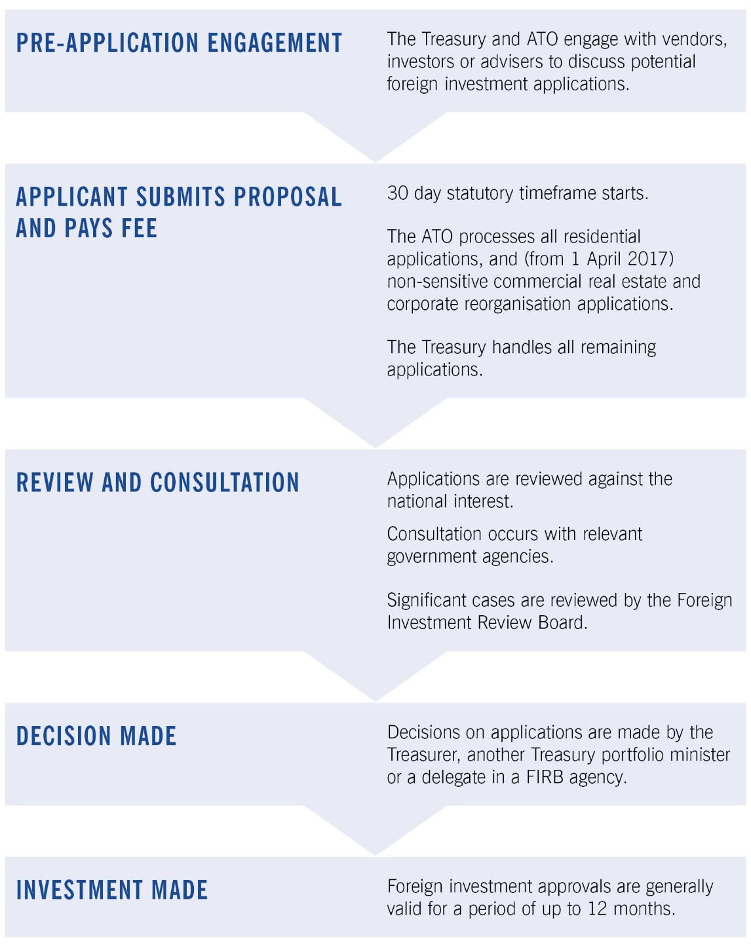

Appendix D: Glossary
Act | The Foreign Acquisitions and Takeovers Act 1975 (as in force during 2017–18)
Agricultural land | Land in Australia that is used, or that could reasonably be used, for a primary production business. The regulations may provide that land of a specified kind is not agricultural land.
Commercial land | Land in Australia or the seabed of the offshore area, other than land:  - used wholly and exclusively for a primary production business; or  - on which there is at least one dwelling (except commercial residential premises); or  - on which the number of dwellings (except commercial residential premises) that could reasonably be built is less than the number prescribed by the regulations  (10, during 2017–18).
Established dwelling | A dwelling (except commercial residential premises) on residential land that is not a new dwelling.
Exemption certificates | Advance approval to allow foreign persons to undertake a program of acquisitions of land and/or business and entities. These are granted with a specified monetary limit within a defined region or sector and generally include conditions requiring the foreign person to report actual acquisitions and any other conditions that would normally be applied for the type of land and/or business and entity to be acquired. Business exemption certificates were introduced on 1 July 2017. Prior to 1 December 2015, the equivalent to land exemption certificates was known as an annual program certificate.

Foreign government investor | A foreign government investor includes:  - a foreign government or separate government entity; or  - a corporation or trustee of a trust in which:  - a foreign government or separate government entity, alone or together with one or more associates, holds a substantial interest (that is, an interest of at least 20 per cent);  - foreign governments or separate government entities of more than one foreign country (or parts of more than one foreign country), together with any one or more associates, hold an aggregate substantial interest (that is, an interest of at least 40 per cent); or  - a general partner of a limited partnership in which:  - a foreign government or separate government entity, alone or together with one or more associates, holds an interest of at least 20 per cent;  - foreign governments or separate government entities of more than one foreign country (or parts of more than one foreign country), together with any one or more associates, hold an aggregate interest of 40 per cent or more; or  - a corporation, trustee or general partner of a kind described in the two dot points above, assuming the references to foreign government (or foreign governments) in those dot points include references to a foreign government investor (or foreign government investors) within the meaning of those dot points.
Foreign person | Foreign person means:  - an individual not ordinarily resident in Australia;  - a corporation in which an individual not ordinarily resident in Australia, a foreign corporation or a foreign government holds a substantial interest;  - a corporation in which two or more persons, each of whom is an individual not ordinarily resident in Australia, a foreign corporation or a foreign government, hold an aggregate substantial interest;  - the trustee of a trust in which an individual not ordinarily resident in Australia, a foreign corporation or a foreign government holds a substantial interest;  - the trustee of a trust in which two or more persons, each of whom is an individual not ordinarily resident in Australia, a foreign corporation or a foreign government, hold an aggregate substantial interest;  - a foreign government; or  - any other person, or any other person that meets the conditions, prescribed by the regulations.
New dwelling | A dwelling (except commercial residential premises) that will be, is being or has been built on residential land and that:  - has not been previously sold as a dwelling; and  - either has not been previously occupied; or if the dwelling is contained in a development and the dwelling was sold by the developer of the development — has not been previously occupied for more than 12 months total.

Ordinarily resident | - An individual who is not an Australian citizen is ordinarily resident in Australia at a particular time if and only if:  - the individual has actually been in Australia during 200 or more days in the period of 12 months immediately preceding that time; and  - at that time:  - the individual is in Australia and the individual’s continued presence in Australia is not subject to any limitation as to time imposed by law; or  - the individual is not in Australia but, immediately before the individual’s most recent departure from Australia, the individual’s continued presence in Australia was not subject to any limitation as to time imposed by law.  - Without limiting paragraph (1)(b), an individual’s continued presence in Australia is subject to a limitation as to time imposed by law if the individual is an unlawful non-citizen within the meaning of the Migration Act 1958.
Residential land | Land in Australia if:  - there is at least one dwelling on the land; or  - the number of dwellings that could reasonably be built on the land is less than the number prescribed by the regulations (10 in 2017–18); and  - does not include land:  - used wholly and exclusively for a primary production business; or  - on which the only dwellings are commercial residential premises.
Substantial interest | A person holds a substantial interest in an entity or trust if:  - for an entity — the person holds an interest of at least 20 per cent in the entity; or  - for a trust (including a unit trust) — the person, together with any one or more associates, holds a beneficial interest in at least 20 per cent of the income or property of the trust.
Temporary resident | An individual who:  - holds a temporary visa under the Migration Act 1958 that allows the individual to remain in Australia for a continuous period of more than 12 months (disregarding the amount of that period remaining); or  - meets the following conditions:  - the individual is residing in Australia;  - the individual has applied for a permanent visa under the Migration Act 1958;  - the individual holds a bridging visa under that Act that allows the individual to remain in Australia until the application has been finally determined; or  - meets the conditions prescribed by the regulations.
Vacant land | Land is vacant if there is no substantive permanent building on the land that can be lawfully occupied by persons, goods or livestock.

The Board is supported in its responsibilities by Treasury’s Foreign Investment Division and Public Groups and International in the Australian Taxation Office (ATO). Treasury and the ATO are collectively referred to in this report as ‘FIRB agencies’.
The Treasurer has provided delegations to senior officers in FIRB agencies to make decisions on applications that are consistent with the foreign investment framework. Certain applications are decided by other Treasury portfolio ministers rather than the Treasurer.
For information on the economic activity of foreign owned businesses in Australia see Australian Bureau of Statistics (ABS) Catalogue no. 5494.0 – Economic Activity of Foreign Owned Businesses in Australia, 2014-15. Breakdowns by source country and Australian industry factsheets are available from the Department of Foreign Affairs and Trade (DFAT) website.
ABS, Catalogue no. 5352.0 – International Investment Position, Australia: Supplementary Statistics. Foreign Direct Investment (FDI) is related to when a foreign entity makes an investment that gives control or a significant degree of influence on the management of an enterprise. It tends to be associated with a lasting relationship. For the statistical definition of direct investment, see Chapter 6 of the IMF's Balance of Payments and International Investment Position Manual (BPM6).
For more detail please see the ‘Foreign Investment Outlook’ box at page 22.
More information is available on the Department of Home Affairs website under ‘Security of Critical Infrastructure Act 2018’.
The Hon Peter Dutton (Minister for Home Affairs), Telecommunications sector security reforms come into force, media release, Parliament House, Canberra, 18 September 2018.
The CHIIA database is available online on the CHIIA website.
See ABS Catalogue no.: - 5302.0 – Balance of Payments and International Investment Position, Australia, which provides the overall investment trends; and - 5352.0 – International Investment Position, Australia: Supplementary Statistics, which includes actual foreign investment statistics by investor country or by industry division for inward foreign investment. 5494.0 – Economic Activity of Foreign Owned Businesses in Australia, 2014-15 for information on the economic activity of foreign owned businesses in Australia.
For information on the New South Wales Government’s recent privatisations see NSW Parliamentary Research Service, Issues Backgrounder No. 2, Privatisation in NSW: a timeline and key sources, June 2017.
Comparisons of longer term trends in residential approvals data should be avoided due to the significant behavioural impacts of the introduction of fees from December 2015.
From 1 January 2017, the Foreign Purchase Additional Duty increased from three to seven per cent in Victoria. From 1 July 2017, the Surcharge Purchaser Duty increased from four to eight per cent in New South Wales.
In making an application, foreign persons that operate a substantial Australian business will be required to demonstrate a genuine need to purchase one or more established dwellings to house Australian-based employees. Consideration is given to a number of factors, and approvals will normally be subject to conditions.
This requirement was codified in the Act from 1 December 2015. Starting an Australian business refers to when a foreign government investor starts to carry on an Australian business, or if a foreign government investor already carries on an Australian business, the business starts a new activity under the Australian and New Zealand Standard Industrial Classification (ANZSIC, 2006) Codes and the activity is not incidental to an existing activity of the Australian business and the activity is within a different Division under the Codes. For a foreign government investor that already carries on an Australian business, starting a new business excludes when they establish a new entity, alone or with others, to undertake the same Australian business or acquire interests in such an Australian business.
The methodology for reporting on investor countries has changed from primarily being based on likely country of control of the foreign person to country of beneficial ownership of the foreign person. This broadly aligns investor country reporting for FIRB data with ownership reporting in the foreign ownership registers for agricultural land, water entitlements and residential land. Where a portion of beneficial ownership is not known or not disclosed, this may be recorded against country of control or allocated based on other factors, such as likely underlying investor countries based on geographic location (see Appendix B for further detail). The practical effect of this approach is that proposed investment by some countries will be overstated and for others understated.
Available on the FIRB website.
This refers to both the Act and other applicable legislation.
This figure includes 260 new cases that were identified in 2016–17 but carried forward into 2017–18 to be actioned.
Data from 2014–15 is compiled by reference to the Australian and New Zealand Standard Industrial Classification (ANZSIC, 2006) and the FIRB is no longer reporting on resource processing.
The following classifications only apply where notification is required because a threshold for the acquisition of such an interest in land is met.
Interim Orders are not available for exemption certificate applications.

